Week 6: Elaborating Relationships

Example 1: Attitudes to wronglaw, comparing gender and age
Before we begin elaborating relationships we should first ensure we understand the nature of the two-way relationships between the variables we are analysing, in the same way that we look at the frequencies before commencing crosstabulations. In this example we are considering the relationships between attitudes to the law, age and gender. We begin with the two bi-variate crosstabulations; attitudes by gender and attitudes by age.

zwronglaw * Sex of respondent Q44 Crosstabulation
 |  |  | Sex of respondent Q44 |  | Total
 |  |  | Male | Female
zwronglaw | Agree | Count | 728 | 783 | 1511
 |  | % within Sex of respondent Q44 | 44.3% | 42.1% | 43.1%
 | Neither | Count | 493 | 657 | 1150
 |  | % within Sex of respondent Q44 | 30.0% | 35.3% | 32.8%
 | Disagree | Count | 422 | 419 | 841
 |  | % within Sex of respondent Q44 | 25.7% | 22.5% | 24.0%
Total |  | Count | 1643 | 1859 | 3502
 |  | % within Sex of respondent Q44 | 100.0% | 100.0% | 100.0%

Chi-Square Tests
 | Value | df | Asymp. Sig. (2-sided)
Pearson Chi-Square | 12.124ª | 2 | .002
Likelihood Ratio | 12.150 | 2 | .002
Linear-by-Linear Association | .125 | 1 | .723
N of Valid Cases | 3502 |  | This is a statistically significant relationship. There is a relationship between attitudes and gender, where females tend to cluster more in the middle category of the variable.
a. 0 cells (.0%) have expected count less than 5. The minimum expected count is 394.56.

zwronglaw * zrage Crosstabulation
 |  |  | zrage |  |  | Total
 |  |  | 18-39 | 40-59 | 60+
zwronglaw | Agree | Count | 467 | 526 | 518 | 1511
 |  | % within zrage | 36.0% | 42.4% | 53.8% | 43.2%
 | Neither | Count | 497 | 399 | 254 | 1150
 |  | % within zrage | 38.3% | 32.2% | 26.4% | 32.9%
 | Disagree | Count | 333 | 315 | 191 | 839
 |  | % within zrage | 25.7% | 25.4% | 19.8% | 24.0%
Total |  | Count | 1297 | 1240 | 963 | 3500
 |  | % within zrage | 100.0% | 100.0% | 100.0% | 100.0%

Chi-Square Tests
 | Value | df | Asymp. Sig. (2-sided)
Pearson Chi-Square | 74.509ª | 4 | .000
Likelihood Ratio | 74.277 | 4 | .000
Linear-by-Linear Association | 46.748 | 1 | .000
N of Valid Cases | 3500 |  | This is also a statistically significant relationship, with older people more likely to agree that the law should always be obeyed.
a. 0 cells (.0%) have expected count less than 5. The minimum expected count is 230.84.

Testing the relationship between attitudes and age controlling for gender
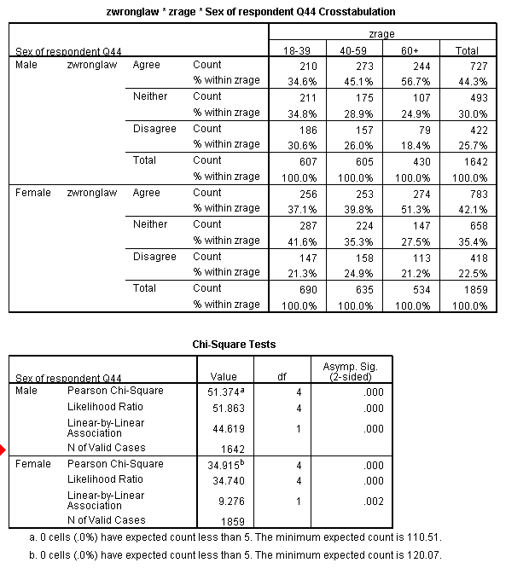

In the first three-way table we are looking at the relationship between age and attitudes, controlling for gender. In other words, is the relationship between attitudes and age the same for both males and females.
There are now two bi-variate tables. One of attitudes by age for males and one of attitudes by age for females. Each table has its own chi-square test. You must ensure that these are valid in the same way as for a bi-variate table. You can then look at the significance of the relationships. In this table we see that there is a significant relationship between attitudes and age for males and a significant relationship between attitudes and age for females.
Looking back at the table we can see that the same basic pattern is present in both, with older people more likely to agree that the law should be obeyed, but we can also see that the age differences are a little less marked among women than men. (For men the difference between the oldest and youngest age group is 57% compared with 35%, for women this is 51% compared with 37%). There is also a much greater difference according to age for women in the proportion falling into the middle category, whereas for men there are age differences but these are smaller.
Attitudes by gender controlling for age
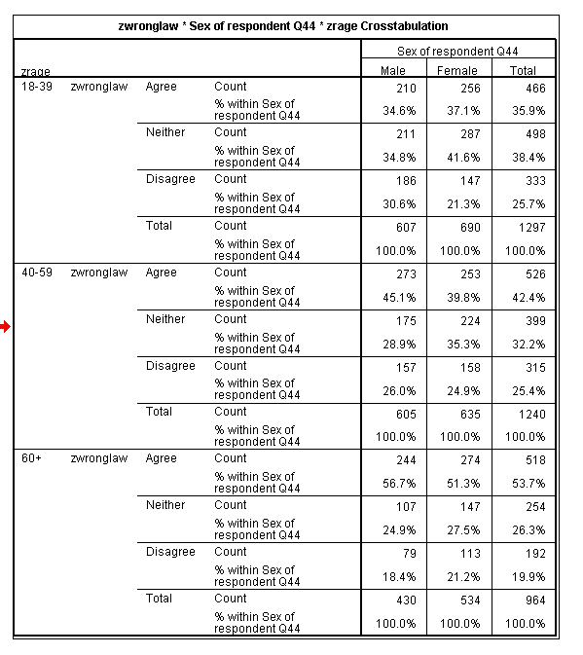
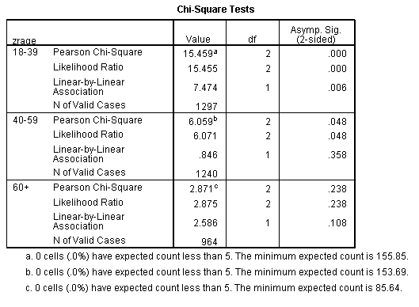

We can also analyse the data in a different way to ask a different question. If we look at the relationship between attitudes and gender, controlling for age we are looking to see if the differences between males and females (especially the propensity for females to cluster more in the middle category) persists within age groups.
To do this we have changed the table so that gender is now the independent variable and age is the control variable, we now have three bi-variate tables one for each age group and consequently three chi-square tests. Again each one should be checked for validity before looking at the significance of the test. Each test is valid in this case.
Looking at the three relationships:
- The relationship between attitudes and gender is significant in the 18-39 age group.
- The relationship between attitudes and gender is significant in the 40-59 age group (though the significance level for this group is marginal)
- The relationship between attitudes and gender is not significant in the 60+ age group. There is no statistically significant difference in the attitudes of males and females in this age group.

Example 2: Attitudes by housing tenure controlling for age

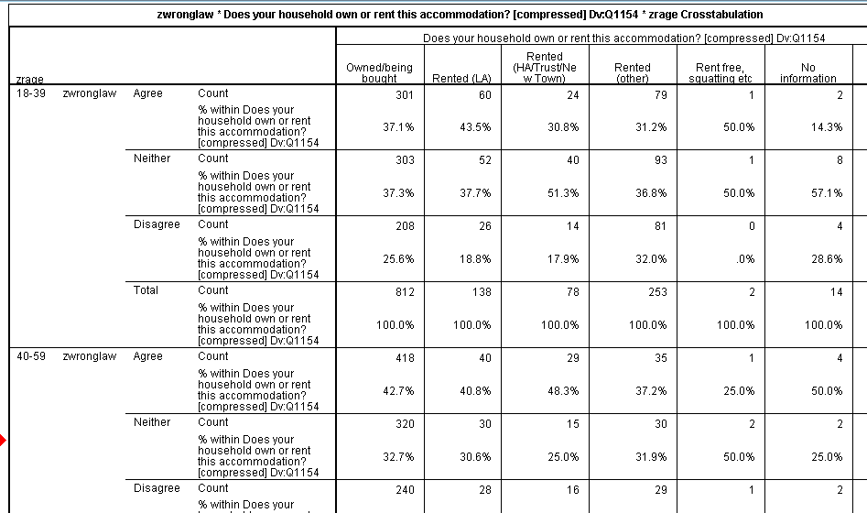

This is just an extract of the complete table. The chi-square tests are shown on the next page.

Chi-Square Tests
zrage |  | Value | df | Asymp. Sig. (2-sided)
18-39 | Pearson Chi-Square | 20.560ª | 10 | .024
 | Likelihood Ratio | 21.257 | 10 | .019
 | Linear-by-Linear Association | 4.612 | 1 | .032
 | N of Valid Cases | 1297
40-59 | Pearson Chi-Square | 5.026^{b} | 10 | .889
 | Likelihood Ratio | 5.027 | 10 | .889
 | Linear-by-Linear Association | .727 | 1 | .394
 | N of Valid Cases | 1242
60+ | Pearson Chi-Square | 6.893^{c} | 10 | .735
 | Likelihood Ratio | 6.562 | 10 | .766
 | Linear-by-Linear Association | 2.730 | 1 | .098
 | N of Valid Cases | 965
a. 4 cells (22.2%) have expected count less than 5. The minimum expected count is .51.
b. 6 cells (33.3%) have expected count less than 5. The minimum expected count is 1.02.
c. 6 cells (33.3%) have expected count less than 5. The minimum expected count is .60.

In this example, the chi-square test is not valid for any of the three age groups. The reason for this is that small groups (Rent free, No information) have been left in the analysis. We can remove those groups to make the tests valid (as shown below).

Chi-Square Tests
zrage |  | Value | df | Asymp. Sig. (2-sided)
18-39 | Pearson Chi-Square | 9.515ª | 4 | .049
 | Likelihood Ratio | 9.427 | 4 | .051
 | Linear-by-Linear Association | 1.003 | 1 | .317
 | N of Valid Cases | 1028
40-59 | Pearson Chi-Square | 2.293^{b} | 4 | .682
 | Likelihood Ratio | 2.334 | 4 | .675
 | Linear-by-Linear Association | .005 | 1 | .945
 | N of Valid Cases | 1136
60+ | Pearson Chi-Square | 4.353^{c} | 4 | .360
 | Likelihood Ratio | 4.248 | 4 | .373
 | Linear-by-Linear Association | 1.361 | 1 | .243
 | N of Valid Cases | 919
a. 0 cells (.0%) have expected count less than 5. The minimum expected count is 18.82.
b. 0 cells (.0%) have expected count less than 5. The minimum expected count is 15.00.
c. 0 cells (.0%) have expected count less than 5. The minimum expected count is 10.83.

The tests are now valid for each age group. Looking at the relationships we can see that
- There is no relationship between housing tenure and attitudes for those aged 40-59 or those aged 60+
- The relationship between attitudes and housing tenure is on the margins of statistical significance for the youngest age group, given this weak significance level and a lack of a theoretical justification for such a relationship we would be cautious in stating that there is a relationship among this group.
Example 3: Attitudes by ethnic group controlling for gender

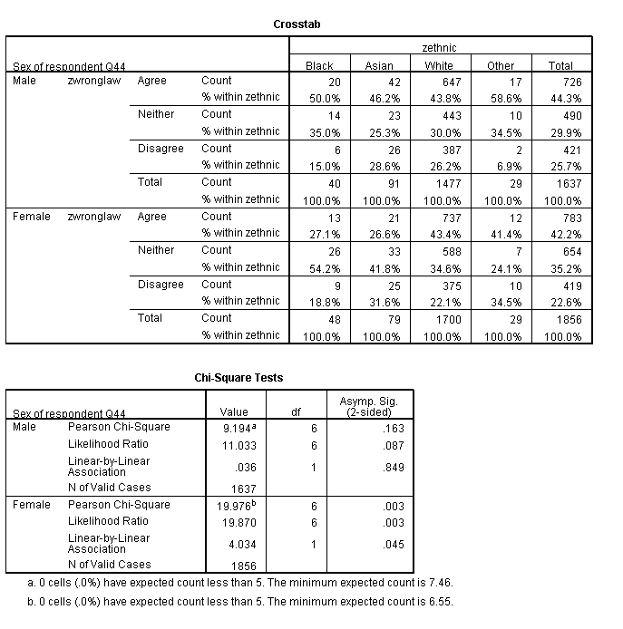
In this example both chi-square tests are valid. However for males there is no relationship between attitudes and ethnicity while for females there is a significant relationship between attitudes and ethnicity.

Example 4: Attitudes and ethnicity controlling for age

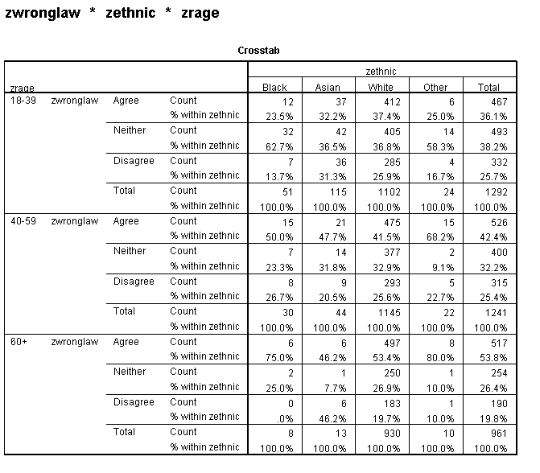
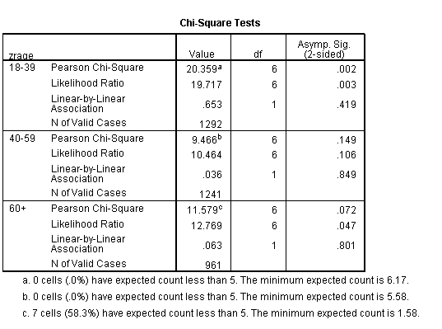
In this example the test is valid for the two youngest age groups but not valid for those aged 60+. The reason for this there are only a small number of non-white respondents aged over 60. There are two options here

- Report the chi-square tests just for the youngest age groups and indicate that there is not sufficient data to make conclusions about the relationship between ethnicity and attitudes in the oldest age group.
- Run a comparison for Over 60’s which just compares White vs. All Others

