Working with International Data
on Government Finances

0. Case Study Learning Outcomes

Having successfully studied this case, you will be able to:

Knowledge and Awareness
- Describe and explain the data production process from data search to data interpretation
- Identify distinctive challenges of working with data on government finances in an international economic analysis
- Describe methods of economic analysis which involve working with international public finances data

Skills, Qualities and Attributes
- Search, select, transform, present, describe and interpret published data sets in ways which support economic analysis
- Apply quantitative methods in an international economic context
- Apply economic analysis with the support of international data

1. Introduction: Data Use

Many organisations, in the public and private sectors of the economy, demand international data about governmental or other public sector finances. Concisely-presented figures on public revenues and expenditures across the world, including any trends or variations, can be valuable information for their decision making.

A wealth of public finance data on many countries is available. We can obtain figures on total flows or on particular categories or components of flow. We can track expenditures and receipts, including the gap between them, over time and between countries and the accumulated stock of debt. Economists are often employed by organisations to work with data of that type.

Patterns in countries’ public finances frequently made the headlines during and following the international financial crisis of the late 2000s. Particular attention has focused on public sector borrowing; the excess of spending over receipts, and also the vast accumulating stocks of debt in some countries.

Economists invariably disagree about the mechanisms through which public finance variables may affect the global economy. The economic impact of public sector deficits and the sector’s stock of debt are perpetually in dispute. Nonetheless, any deficit must be financed (`funded’) and any debt interest owing must be paid (or otherwise `serviced’). Therefore, financial institutions and investors will have a keen interest in the trends in countries’ public finances.

More generally, many businesses trade in more than one country. Changes in the fiscal stance or fiscal health of a country are considered by businesses, in deciding which markets to exploit or where to deploy their scarce resources.

Data can also be used to inform public policy decisions about the use of taxation or public expenditure (fiscal policy). For example, national governments may study international evidence when considering changes to variables such as tax rates or specific classes of expenditure. In other words, they use international comparisons to `benchmark’ local policies, practices or performance; before deciding what changes to make.

Working with data on the public finances which span national boundaries often adds to the complexity of analysis. For example, data sources and series of data for different nations are less likely to be consistently comparable and compatible with each other. Extra caution is required when interpreting the results derived from them (see below, in Section 3).

2. Data Search and Selection

In this case study, we select published quantitative data about aspects of national government, for 6 countries including the UK. One criterion for selecting the countries is relative accessibility of relevant, reliable and comparable secondary data.

Public finance data for a cross-sample of countries is available from several international organisations including the European Union, the World Bank and the OECD. In this Case Study, we choose to employ data from the Word Economic Outlook published by the International Monetary Fund.

The Economic Outlook database contains long runs of public finance data for many countries, and also features forecasts for the next few years. The dataset enables us to identify the structural (noncyclical) elements of government finances as well as the cyclical elements (see explanation in Section 3, below).

One possible problem of working with the Economic Outlook dataset is its sheer enormity containing, as it does, comprehensive coverage both of countries and of measurable economic variables. Nonetheless, a common issue when working with international data sets is that the span of available time series data for some countries can vary.

Gaps in data place some limits on the reliability of international comparisons. Consequently, judgement is always required to decide whether any international differences between data sources might distort the comparisons made and any implications we might draw from them.

If so, options include: seek transformations of the data available to remedy the risk of distortion; accept the data as they are and interpret them with extra caution, or reject them altogether (with or without seeking alternative data sets). Sound judgements about which of these options to pick are part science, part art but they do at least seem less difficult to make after some experience of making them.

The selection we have made of 6 countries will enable us to reveal some commonality, and also some national differences, of data patterns across the world. The selection also enables some careful generalisations to be made about a wider range of countries or regions.

No 6 countries, however, will be fully representative of everywhere in the world, in respect of national or regional patterns in the public finances and the reasons for them. For example, the selection excludes Eastern Europe, most of Asia and South America.

We write this Case Study in mid-2011, when there is a spectacular reason for exploring data like these. Widespread uncertainty and concern is voiced about consequences of financial problems affecting whole countries within the financial grouping called the Eurozone: specifically, Greece, Ireland, Portugal and Spain.

We have chosen to includes one of these four countries in our sample. Our overall choice of countries reflects the specific purpose of this Case Study, which is to introduce this type of analysis to you. However, you may wish to repeat the analysis you read about in this Case Study for these other countries. See below our Section 5: Summative Assessment Task.

3. Data Transformation and Interpretation

A popular starting point for thinking about governmental finances is to consider international differences in the scale of expenditures. One way to do this is to compare the size of general government expenditures in each country, relative to its own GDP. Being a percentage (a ratio), so without volume or currency units, such a figure is useful for international comparisons, not only at one point in time (cross section) but also across time (longitudinal).

Chart 1: General Government Expenditure to GDP, %
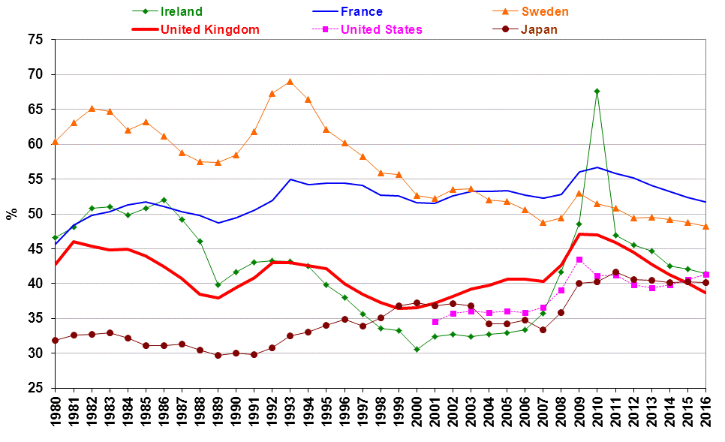
Source: World Economic Outlook Database, April 2011, International Monetary Fund.

Chart 1 plots general expenditure, relative to GDP, for our 6 countries since 1980. It shows a tendency for differences in the size of government spending, relative to GDP, to narrow over time; albeit with individual and occasional exceptions. The decline in Sweden ratio is particularly marked; falling by around 20 percentage points across the period, including projections ahead of the time of writing. The UK ratio, during the same period, is typically near the middle of the range across the 6 countries in the sample.

The term `general government net lending’ refers to the extent to which revenue exceeds expenditure. In other words, it is a measure of a government’s financial surplus. When making comparisons across time and across countries, for economic meaning and for standardisation purposes, it is common to consider net lending in a country relative to its GDP. Chart 2 displays that ratio for the 6 countries.

Chart 2: General Government Net Lending relative to GDP, %
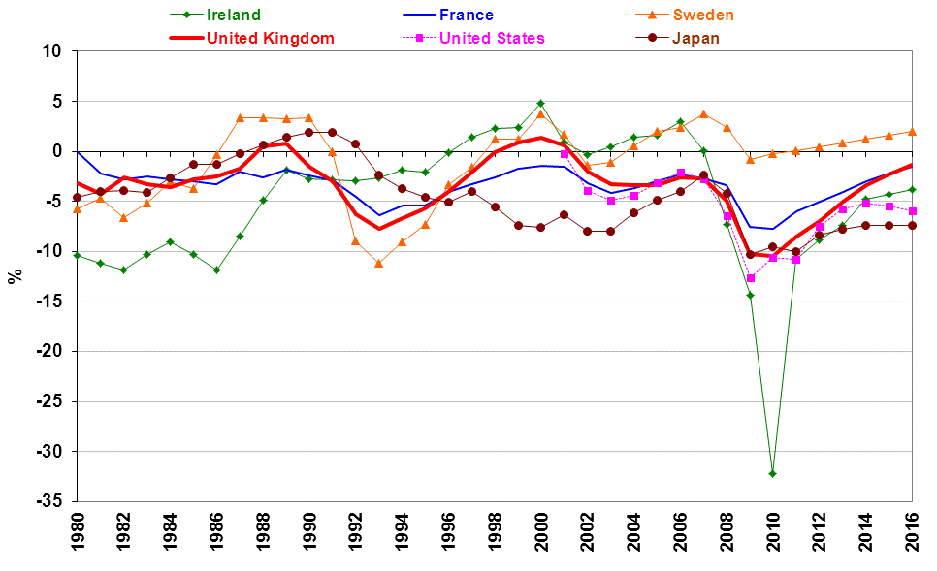
Source: World Economic Outlook Database, April 2011, International Monetary Fund.

One feature of Chart 2 is the prevalence of observations consistent with general government deficits. In other words, for most of these countries during this period, general government has usually been a net borrower; its expenditures exceeding its receipts. Sweden is a partial exception, having budget surpluses more often than have the 5 other countries, including much of the period around and since the millennium. From 1993-2012, the UK general government is shown as a net borrower to the equivalent of 4 per cent of GDP, on a par with the US and France ratios. Japan has a been larger net borrower, more than 6 per cent of GDP.

One problem of interpreting figures for net lending (or net borrowing), as a measure of the general government’s budget surplus (deficit), is the extent to which they might reflect deliberate government policy. The size of net lending is affected by the state of the economy. In a cyclical downturn in economic growth, the amount paid in income-related taxes might be relatively low. On the other hand, the rate of unemployment might be relatively high and hence the amount paid out in unemployment benefits also high.

The combined effect of reduced tax revenues and increased benefits, during cyclical downturns, tends to increase the likelihood of general government deficits or else smaller surpluses. The opposite would be true during a cyclical upturn in economic growth (around a `boom’): general government would tend to run smaller deficits or larger surpluses during that phase of the cycle.

One way to see past the cyclical impact of the economy on government finances is to try and estimate what the size of expenditures and revenues would be, if actual output of the economy fully matched its potential. `Potential output’ is defined as the quantity consistent with normal utilisation of productive capacity.

Consequently, figures are sometimes subjected to a technical transformation by being cyclically-adjusted; that is, statistical methods are used to eliminate the cyclical component from the overall figures. That transformation leaves an indicator of what is termed the `structural’ component of the government finances which, by definition, is unaffected by cyclical influences. Chart 3 shows estimates of cyclically-adjusted net lending, relative to GDP, for our 6 countries.

Chart 3: Cyclically-adjusted Net Lending relative to GDP, %
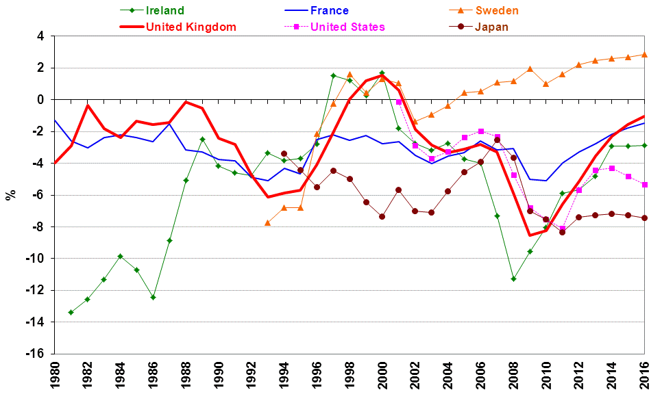
Source: World Economic Outlook Database, April 2011, International Monetary Fund.

Chart 3 shows a tendency for countries to run structural deficits: they are the negative percentage figures. The one exception, especially over the past decade, is the case of Sweden. The UK average structural deficit since 1980 is just short of 3 per cent of its GDP.

Budget deficits or surplus are an example of what economists refer to as a `flow concept’. By contrast, debt (which might accumulate over a number of periods) is a `stock concept’. A country’s budget balance is determined by a flow of payments and receipts per period. Typically, as we have seen, governments run deficits, so they must borrow money in order to fund them. In doing so, they accumulate a stock of debt. Budget surpluses (net lending) enable governments, if they so choose, to repay and so reduce their stock of debt.

Chart 4 indicates, for our 6 countries, the accumulated stock of general government debt at the end of each year, relative to the annual flow of GDP. This common method is also used in respect of other holders of debt, including firms and households. It is important to recognise that we are comparing an outstanding stock of debt (at one point in time) with a flow of income over a 1-year period.

Chart 4: General Government Gross Debt relative to GDP, %
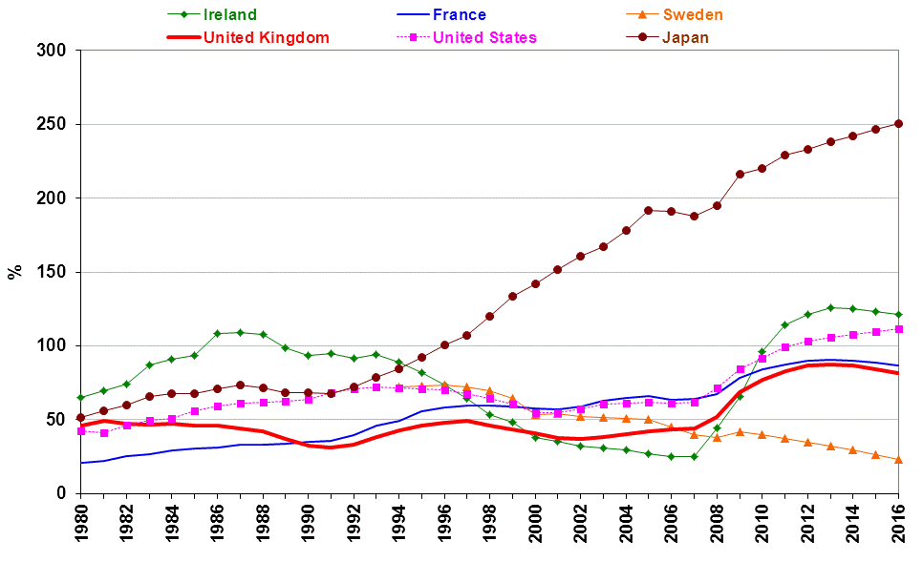
Source: World Economic Outlook Database, April 2011, International Monetary Fund.

Chart 4 shows how, with the exception of Japan, national governments had managed to either stabilise or reduce their debt-to-GDP ratios prior to the deep financial crisis of the late 2000s. Japan was a notable exception, the ratio quadrupling between 1980 and 2009. Following financial and economic crisis, which saw governments use fiscal policy to support aggregate demand and to ensure the stability of the financial system, debt-to-GDP ratios rose rapidly. The exception is the case of Sweden, whose budget surpluses enabled early repayment of government debt.

4. Review Questions

1.
In the context of published secondary data on government or public finances, what are the main stages in the data production process undertaken in this Case Study?

2.

(a) What do you understand by the term ‘general government’?

(b) If, over a given period of time, expenditure by general government exceeds its receipts would government be a net lender or a net borrower?

(b) List the public finance variables relating to general government covered in this Study. What other public finance variables might be of interest for analysis?

3.

(a) Describe any common national long term and short term patterns you observe in the public finances variables data presented in this Study.

(b) Describe any nationally distinctive patterns you see in those data.

4.

(a) What purposes are served by presenting nominal public finance variables relative to nominal GDP?

(b) In comparing the size of the general government debt relative to GDP we are comparing a stock with a flow. Explain what this means and the possible rationale for doing this.

(c) If we were using quarterly data rather than annual data, what considerations or adjustment would we need to make when comparing government debt relative to GDP?

5. This is a question for reflection and possible further study.

Identify those factors you think could affect, from one period to another, the magnitude of general government expenditure and general government receipts.

Do you think the factors you have identified might be part of an explanation of any of the patterns you have described in your answer to Question 2 above?

5. Summative Assessment Task

Locate the World Economic Outlook database. Repeat the analysis of this Case Study, but for a selection of countries of your choice.

6. Data Appendix

Source: World Economic Outlook Database, April 2011, International Monetary Fund.

http://www.imf.org/external/ns/cs.aspx?id=28

This Case Study was designed and authored by: Dean GARRATT and Stephen HEASELL, of Nottingham Business School, Nottingham Trent University with acknowledgment of funding from The Economics Network, the subject Centre for Economics of the UK Higher Education Academy.

The World Economic Outlook Databases can be accessed at http://www.imf.org/external/ns/cs.aspx?id=28

