Estimating a demand curve for un-priced environmental goods

1. Introduction
For conventional goods and services, market transactions provide important information about their value to consumers. However, our countryside, waterways and the coast, along with their associated flora and fauna, are rarely traded in the same way as cars, music downloads or clothes. Nevertheless their existence can generate substantial benefits to many people and their destruction is often portrayed as a negative consequence of economic progress.

The aim of this brief is to consider an approach which can be used to place a value on an un-priced environmental asset: the Travel Cost Method (TCM). As its name suggests, the technique is underpinned by the idea that by incurring time and money costs, consumers are revealing a willingness to pay for a particular location, even if they do not have to pay a formal entry fee.

This brief divides into four further sections. Section 2 introduces the term consumer surplus, a concept which will be important later on in our discussion. Following on, we shall look briefly at the types of benefit that environmental resources provide for society. Section 4 develops a worked example of the TCM, while Section 5 contains some questions for discussion.

2. Consumer Surplus
Since individuals vary with respect to their tastes and preferences, differences exist in the amount of money each is willing to pay for a good or service. Usually, retailers sell products at a “take it or leave it” price. If this price exceeds the value an individual places on a commodity, s/he will not buy it. If, on the other hand, the price is equal to or less than a consumer’s own valuation of the product, s/he would consider buying it, depending upon the other consumption opportunities that are available and the amount of money available to spend.

If an individual buys a product for a price below his/her own valuation of it, s/he is said to have derived consumer surplus from the purchase. Figure 1 shows the concept of consumer surplus diagrammatically. Line D denotes the market demand curve for a product. P* is the product’s price. The demand curve shows that there are some people whose valuation of the product exceeds P*. These consumers all receive consumer surplus.

The total value of the consumer surplus can be measured as the shaded triangle in Figure 1. The rectangle labelled ‘A’ represents the revenue that the seller is receiving from selling Q* units of the commodity at a price of P*.
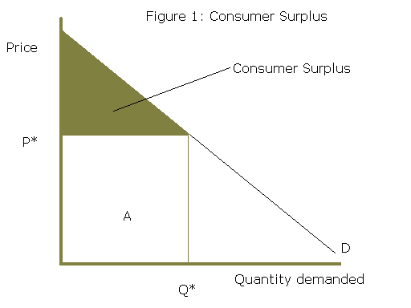
At this point, one might ask “why can’t the seller convert this consumer surplus into revenue?” The answer rests with practicality. Although each individual has a maximum price s/he is willing to buy a commodity, there is no incentive not to reveal this information. Why pay a higher price than you need to?

The closest we get to sellers being able to extract some consumer surplus from buyers occurs in auctions (such as E-bay) where people keep bidding until the price rises above the maximum amount they are willing to pay. Eventually, the person who is willing to pay the highest sum for the product is left to buy it. Note of course that this may not eliminate consumer surplus entirely as the eventual winner may still be paying less than her/his own valuation of the product.

Although auctions may be a cost-effective way of selling items such as antiques, it would be totally impractical for high-street stores to auction off every item of stock as the time and financial costs, for buyers and sellers alike, would be enormous.

Referring back to Figure 1, it can be seen that the value of a traded product is made up of two elements. First the total revenue that accrues to the producer (A) and second, the consumer surplus enjoyed by purchasers.

However, not all products have an explicit price. Many environmental assets, such as beaches or the countryside, do not have a user fee. This does not mean that the site has no market value. Consumers must expect to gain utility from the site by the very fact that they have opted to visit it. This leaves us with a problem: at a zero price there must be consumer surplus, since demand is positive, yet there is no discernable demand curve from which we can estimate it!

3. Valuing Environmental Goods
The value of our natural environment extends beyond that of people who use it directly, for example walkers and water-users. Some individuals would like the option to visit an area of natural beauty sometime in the future, even if they haven’t yet visited it so far. This is known as option demand, a concept which applies also to facilities such as hospitals (most individuals derive a benefit from knowing that medical facilities are available should an illness befall them in the future).

Furthermore, there are people who have a demand for the natural environment, not because they hope to use it themselves, but because they would like other people and future generations to be able to enjoy it. This is referred to in the economics literature as existence value. In the environmental economics literature, the term total economic value is the sum of all these demands: actual use value + option value + existence value.

Estimating option and existence values is a particularly difficult task since individuals are not revealing their preferences explicitly in a marketplace situation. Thus, for the purposes of this brief, we shall consider something a little easier: how we might estimate the user benefits from a park that currently does not have an entrance fee.

4. The Travel Cost Method
The simplest version of the Travel Cost Method (TCM) is the zonal method. Using this approach, the researcher identifies an array of concentric circles around the site in question. For simplicity, we shall consider 5 (A to E). Each of these zones is defined in terms of the travel cost needed to get to the site.
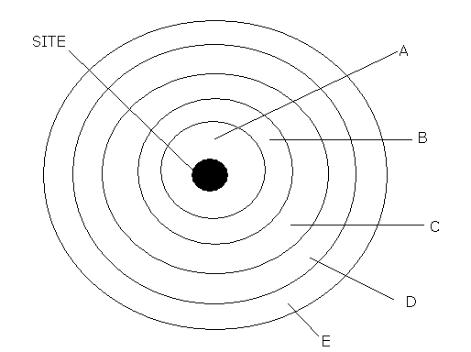
The area of each zone is likely to increase as we get further from the site. This may well mean that zones further from the site will be associated greater populations than those closer to the site.

Using survey responses, site visitors can be allocated to each of the defined origin zones. This enables us to calculate a visit rate for each zone using data on zone population sizes. Although we would expect the visit rate to be negatively correlated to distance travelled, we may find that the actual number of visitors from more distant zones may exceed those from closer zones.

Table 1 sets out a hypothetical example.
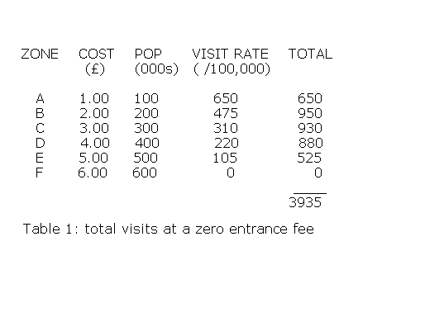
Assuming that the site does not charge an entry fee, we can first identify the number of visitors, in this case 3935. In terms of a demand curve, 3935 is the point at which the curve cuts the horizontal quantity axis (which, in this case would be labelled ‘visitors’). However we do not yet know any other point on the demand curve.

Using the TCM, it is possible to extrapolate further points along the demand curve. The logic works as follows. Hypothetically, if the owners decided to charge a £1 entry fee, visitors from Zone A will now incur a cost of £2 to enjoy the site (£1 entry fee + £1 travel cost). If so, visitors from Zone A are postulated by the TCM to exhibit the same visit rate as people from Zone B had done when they face a zero entrance fee but the £2 travel cost.

This logic can be extended through the other zones, with Zone B visitors (who now face the hypothetical £1 entry fee) having the same visit rate as Zone C visitors without an entry fee. This process is outlined in Table 2.
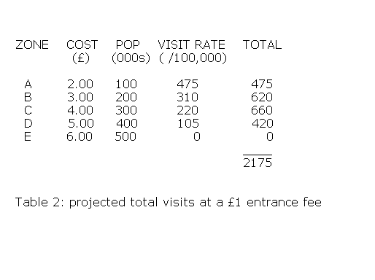
It can be seen that people from Zone E (who now face a £6 overall cost [£1+£5]) are now projected not to visit the site in the same way as Zone F people had chosen not to when they faced £6 in travel costs. Thus, we now have the second point on our demand curve: if a price of £1 was to be levied, the predicted number of visitors would equal 2175.

This exercise can now be taken a stage further, this time assuming a hypothetical entry fee of £2. Now, Zone A visitors would face an overall cost of £3 (£2 [hypothetical entry fee] plus the actual travel cost of £1). Thus following the same logic as before, Zone A visitors will now be assumed to visit the site at the same rate as Zone C visitors (who face £3 of travel costs but no entry fee). The process can be expanded for the other zones, with Zone D visitors now being deterred altogether. This is set out in Table 3.
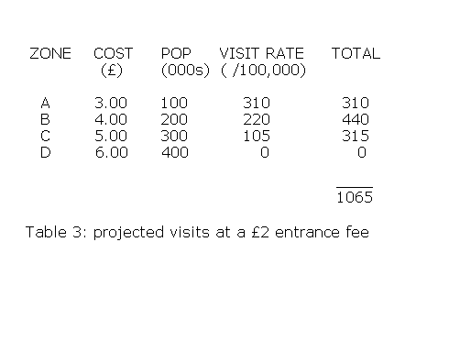
Thus, we now have a point on the demand curve for an entrance fee of £2 (1065).

The next stage is to replicate the same analysis for a hypothetical entrance fee of £3. This time, Zone C consumers are projected to cease visiting the site, with a predicted total of 430 visitors from Zones A and B. This is set out in Table 4.
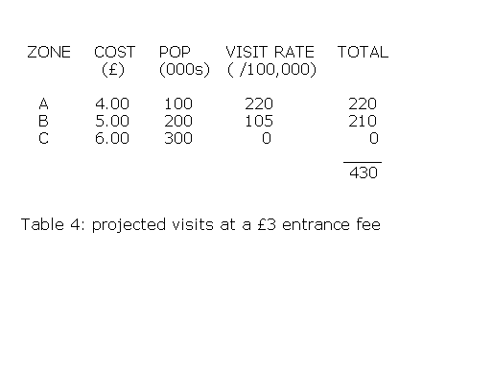
The figures contained in Table 5 complete the analysis for the hypothetical entrance fees of £4 and £5. In the former case, only Zone A people still visit the site and in the latter, all visitors are deterred from visiting the site.
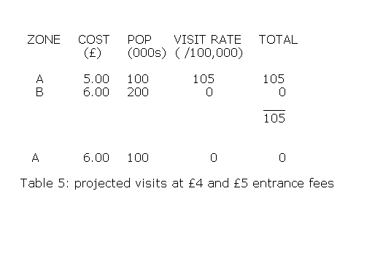
If we take all the estimated visitor totals for each of the hypothetical entrance fees, we can derive a ‘travel cost demand curve’. This can be seen in the diagram below.

It should be re-emphasised that in reality the site owners are not actually charging an entrance fee. However, by introducing successive hypothetical increments to the entrance fee, we can extrapolate a demand curve.

We are now in a position to estimate the benefits being generated by the site. In terms of consumer surplus outlined in Section 2 of this brief, we simply need to calculated the area underneath the whole demand curve (since the price, in reality, is zero). Thus, let us assume that the demand curve equation is:

[1] $P=α−βQ$
where P denotes entry fee and Q denotes the number of visitors. The area under the demand curve can be estimated as

$\int{(α−βQ)\text{dQ}}$ [2]

where Q’ is the level of visits when P=0 and ∫ is the integral sign. This calculation involves the area under the whole demand curve since the site is zero priced. Thus we are using a definite integral as we are specifying the range of [1] (namely from Q=0 through to Q=Q’) under which we wish to determine the area. Strictly speaking, we could consider areas in which Q<0 or Q>Q’. However such outcomes are trivial in the context of a demand curve since the former implies a negative quantity and the latter implies a negative price (i.e. people being paid to visit the site).

5. Conclusions
The TCM is one method by which the benefits generated from a non-marketed good can be estimated. However, the technique is not perfect and relies on a number of assumptions regarding the behaviour of individuals and the other variables that influence the demand for recreation sites.

Tasks

Based upon this brief, readers may wish to:
- consider whether it is right to assume that individuals react in the same way to a change in travel cost as they would to a real entrance fee change;

- calculate the revenue that the site owners would receive if they levied a £2 entrance fee;

- whether the TCM is more suited to evaluating the benefits being generated by sites to which recreationalists must travel a long distance or urban locations which have very narrow catchment populations.

