Measuring inequality: Using the Lorenz Curve and Gini Coefficient

1. Introduction
Almost thirty years ago, the author of this brief attended a lecture addressing the economics of inequality. At the start, the class was invited to imagine the implications of individual wealth being reflected in our personal height. Assume that by government decree, everyone has to march past a fixed point over the period of one hour, starting with the smallest people and ending with the largest. The parade would begin with all the people who owed money. They would march underground. Even after 20 minutes, marchers would be invisible since they had no wealth.

At the half way point, the parade would comprise of dwarves, little more than a few centimetres in height. Only 12 minutes before the end of the parade would people start to be of an average height and hence, of average wealth. In the last few minutes of the parade, marchers would evolve rapidly into giants, assuming heights of several metres. The heads of the last few participants would be invisible since their height would be measured in kilometres rather than metres.

The moral, of what seems to be a trivial example, is that despite increases in living standards, wealth is not distributed evenly through society. The vast majority is owned by the very few.

The degree to which the inequality depicted in the parade of dwarves and giants is undesirable is a normative issue. Commentators concerned with poverty levels in society will argue that one of the major roles of government should involve some degree of re-distribution. If a government is to play a role in such a process, then it needs to be informed about the distribution of wealth (which is a stock and can include a range of assets that include shares, land, houses as well as money) and the distribution of national income (which is a flow since it is paid per week, month, year etc).

The terms wealth and income should not be used interchangeably. The distribution of the stock of wealth will be much more unequal than the flow of income in a given year. As we have already seen in the case of the parade of dwarves and giants, many people have substantial negative wealth. Furthermore, studies based on wealth are a lot less common since it is harder to measure wealth than it is income.

The aim of this case study is to introduce readers to two interlinked methods of measuring inequality: the Lorenz Curve and the Gini Coefficient. Both originate from the early years of the twentieth century: in 1905, Max Otto Lorenz published a paper in an American statistical journal outlining the technique which was to bear his name. Corrado Gini’s index of income inequality was published shortly afterwards in 1914. However, it was the work on poverty and income inequality by Sir Tony Atkinson during the 1970s that led to the popular dissemination and development of the original work of Lorenz and Gini.

2. The Lorenz Curve
Let us assume that we wish to construct a Lorenz Curve to measure wealth inequality. The standard framework can be built up in four stages. First, we draw a set of axes in which the cumulative percentage of wealth is measured along the y-axis while the cumulative percentage of households is measured along the x-axis. Usually, the graph’s axes are closed off to form a box.

The second stage requires us to order the distribution from the smallest through to the largest, thereby enabling us to answer the following sequential questions:
- what proportion of wealth is owned by the poorest 10 percent of the population?
- what proportion of wealth is owned by the poorest 20 percent of the population?
- what proportion of wealth is owned by the poorest 30 percent of the population?

This process continues until we reach the point where 100 per cent of wealth is owned by 100 per cent of the population. The third step is to assume that we live in a truly equal society. If this were to be the case, the relationship would be such that as we move along the x-axis, each 10 per cent increment of households would own an additional 10 per cent of wealth. In this case, the line we would draw would be a straight line emanating from the origin. This is known as the line of absolute equality and will have a slope of 45 degrees.

Finally, we can insert a line that is based on the data set available to us. In this case, the line will bow away from the line of absolute equality. The more unequal society is, the further it will deviate away from the line of absolute equality. It is this line which is known as the Lorenz Curve.
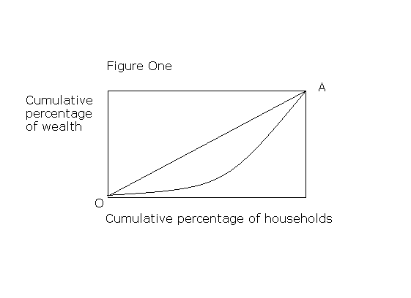
In Figures One and Two, the line of absolute equality is labelled OA. However, the Lorenz curve assumes a different shape in the two diagrams. In Figure One, it can be seen that the poorest sections of society command a very small proportion of the country’s wealth.
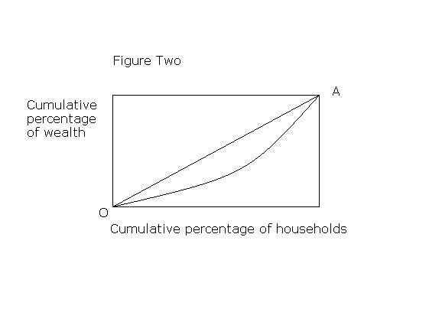In Figure Two, societal wealth remains unevenly distributed, but the poorer households are (on average) better off than they are under the first scenario.

One of the advantages of using the Lorenz Curve is that it provides a visual representation of the information we wish to consider, in this case the inequality of wealth prevailing in society.

We could superimpose several Lorenz Curves onto the same diagram to show changes in the way in which wealth has been distributed across society at various points in time. For example we might wish to compare the years 1945, 1975 and 2005 (see Figure Three).
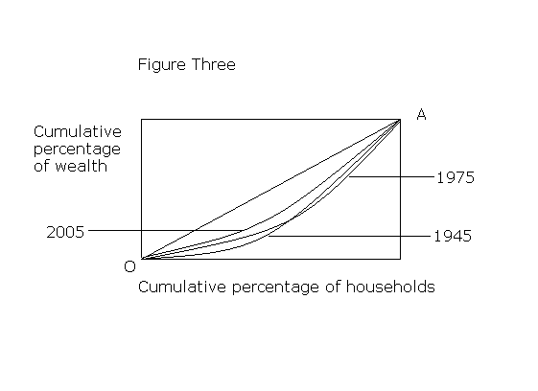Even if the shape of the Lorenz Curve is not changing significantly, poorer members of society may still be much better off in terms of what they can afford to buy. In other words, they are relatively no better off, but in terms of spending power, they have the opportunity to enjoy a wider range of luxury items. Commodities which were considered to be luxuries fifty years ago (for example, televisions and telephones) are now taken for granted by most people.

3. The Gini Coefficient
The Gini Coefficient is a complementary way of presenting information about inequality. It is the ratio of the area between the Lorenz Curve and the line of absolute equality (numerator) and the whole area under the line of absolute equality (denominator). Based on Figure Four, it can be seen that the Gini Coefficient = C/0AB.
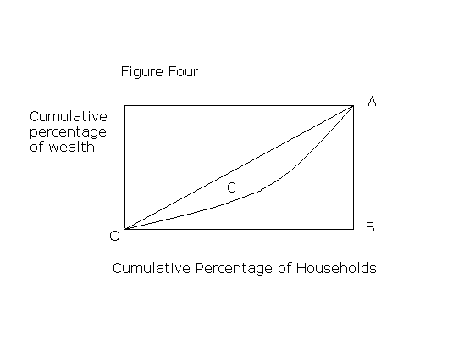The extreme values of the Gini Coefficient are 0 and 1. These are often presented in statistical publications as percentages. Hence, the corresponding extreme values are 0% and 100%. The former implies perfect equality (in other words, everyone in society has exactly the same amount of wealth) whereas the latter implies total inequality in that one person has all the wealth and everyone else has nothing. Clearly, these two extremes are trivial; the key thing to bear in mind is that the lower the figure that Gini Coefficient takes (between 0% and 100%), the greater the degree of prevailing equality.

The Gini Coefficient is an example of a summary statistic. In other words, it compresses a broader array of statistical information into a single figure. We can present Gini Coefficient data in two main ways, first as a time series trend and second as a set of cross section figures. Let us consider each in turn.

Chart 1 presents the Gini Coefficient for the UK since 1981. It is based on the distribution of household disposable income. The rapid increase in inequality during the late 1980s is attributed to a widening of the gap in remuneration between skilled and unskilled workers, together with income tax cuts and a decline in the power of trade unions. Can you think of any reasons why there has been a small improvement in inequality since 2000?

Chart 1: Gini Coefficient 1981-2005/6
Source: The effects of taxes and benefits on household income, 2005-06, Office for National Statistics.

Table 2 provides a cross sectional insight into income equality in fourteen countries plus the European Union. Note that there are variations in the base year. This is common when international comparisons are being undertaken.

Table 2: Distribution of Family Income
Country | Gini, % | Year
Argentina | 48.3 | 2006
Australia | 35.2 | 1994
Belgium | 33.0 | 2000
El Salvador | 52.4 | 2002
European Union | 31.6 | 2003
Finland | 26.9 | 2000
France | 26.7 | 2002
Germany | 28.3 | 2000
India | 36.8 | 2004
Japan | 38.1 | 2002
Morocco | 40.0 | 2005
Nigeria | 43.7 | 2003
Russia | 40.5 | 2005
United Kingdom | 36.0 | 1999
United States | 45.0 | 2004
Yemen | 33.4 | 1998
Source: CIA World Factbook

Consider the following questions before moving to the next section of this brief.
- Which country is the most equal and least equal in terms of family income distribution?
- If you were undertaking a comparative analysis of the fourteen countries listed in Table One based on income distribution, what additional information would you find useful to help you with your study (hint: you may choose to navigate yourself round the CIA’s Factbook)

4. Interpreting Lorenz Curves and Gini Coefficients
It was noted in the introduction that Lorenz Curves and Gini Coefficients can be used to gain insights into a range of cases in which inequality is seen as a policy issue. It is inevitable that there will be considerable variation between countries since, to varying degrees, each will have different resource endowments and institutional norms which will have driven and constrained its historical, political and social development.

It should be emphasised that the figures in Table Two are not telling us which country is the richest. The Gini Coefficients are simply providing information about how each country’s income, large or small, is distributed between families (noting of course that the definition of a family unit will vary from country to country). Furthermore, the fact that two countries have the same Gini Coefficient does not mean that their respective Lorenz Curves are similarly shaped also. If the area C for two countries (see Figure Four) is identical, their Gini Coefficients will also be the same. However one income distribution might be seen as less desirable than the other (as a normative judgement).

There is no reason why the two measures cannot be applied to other scenarios which also have a distributive aspect to them. Perhaps the most common application is to the analysis of industry structure. For example, we could draw Lorenz Curves to measure the distribution of output across firms within an industry. As with wealth or income, the further the Lorenz curve deviates from the line of absolute equality, the more concentrated it is. A similar exercise could be undertaken from the point of view of employment.

Researchers interested in the analysis of competitive balance in sport use Lorenz Curves and Gini Coefficients to estimate the degree to which teams dominate sporting competition.

5. Drawing your own Lorenz Curve
Let’s imagine that an industry that produces plastic turnips is made up of ten firms. Each firm’s contribution to the overall industry output in a given year is as follows:

Firm | Units sold (millions)
A | 25
B | 4
C | 3
D | 12
E | 17
F | 30
G | 20
H | 17
I | 12
J | 10
Total | 150

- Draw the axes that you will use to draw your Lorenz Curve and label your axes appropriately.
- Insert the line of absolute equality. State precisely what this line means in this context.
- Now derive a Lorenz Curve using the hypothetical outputs set out above.
- Are there any other measures that can be used to gain an insight into the degree of concentration in the plastic turnip industry?

The full report can be downloaded at http://www.statistics.gov.uk/downloads/theme_social/Taxes_Benefits_2005-2006/Taxes_Benefits_2005_06.pdf
The figures can be viewed at https://www.cia.gov/library/publications/the-world-factbook/fields/2172.html
The homepage for the CIA Factbook is https://www.cia.gov/library/publications/the-world-factbook/
See the case studies ‘Measuring the competitiveness of sport: are the top teams getting too strong?’ and ‘Is the Scottish Premier League less competitive than its English Counterpart?’

