THE ECONOMICS FESTIVAL
OF MUMBAI

Arth-Manthan

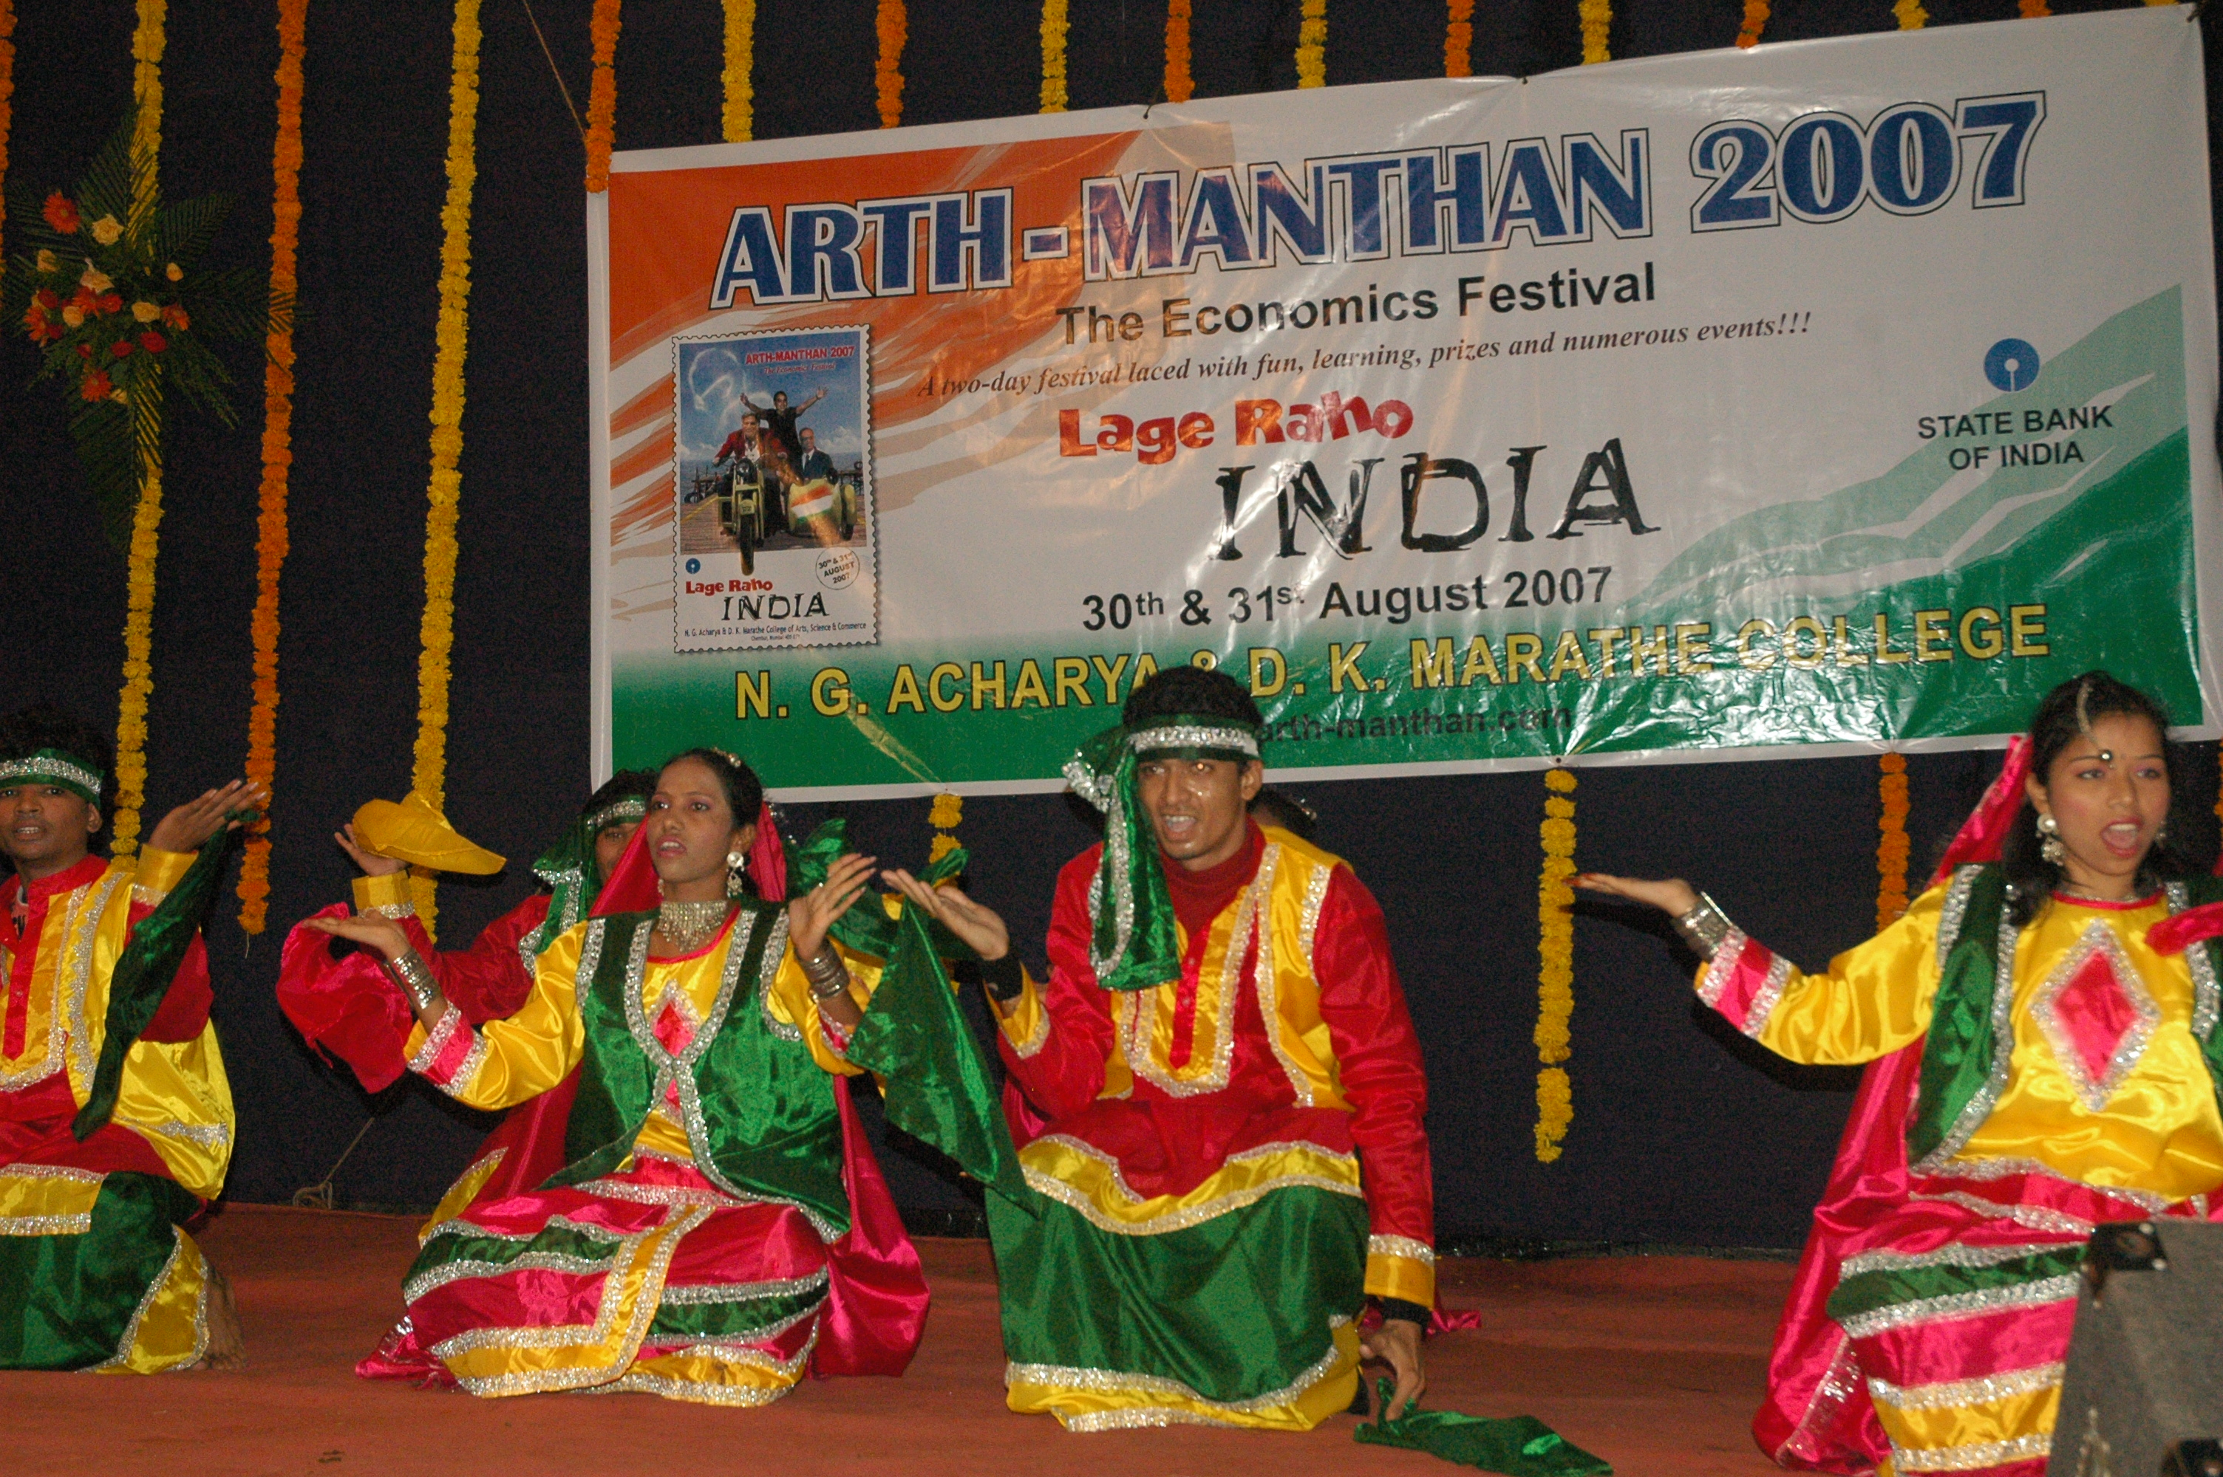

Organised by:
N. G. Acharya & D. K. Marathe College
Chembur, Mumbai

Main Event Sponsors:  State Bank of India

HOW IT ALL STARTED…

A festival based only on economics... well that was unheard of in Mumbai campuses about seven years ago. Unlike many other college festivals that offer a little bit of everything, we decided to focus solely on enhancing students’ interest in economics by bringing the subject to life! That’s how Arth-Manthan – The Economics Festival was born!

We knew that we can create global leaders in Economics only if our young minds are motivated to think the economist way! To start off they must be urged to broaden their horizons and think beyond the classroom! And The Economics Festival was a step towards this…

The festival was started at N. G. Acharya & D. K. Marathe College, Chembur in 2001 to celebrate 10 years of economic liberalisation. Through the festival the college campaigned for further opening up of the economy with a firm belief that it would lead to India finally reaching its tryst with destiny!

The MISSION OF ARTH-MANTHAN" is “To attract and enhance students’ interest in and enthusiasm towards Economics by bringing the subject to life."

RECOGNITION:

Over the years, the festival has received wide coverage in the media and has inspired many other colleges to introduce similar festivals. It has in fact become a forum for industry-academia interaction. The festival is today the largest festival of its kind in India!

THEME:

Arth–Manthan 2007 was held on 30th & 31st August. The theme of the festival this year was ‘Lage Raho INDIA’ – ‘Carry On INDIA’! We celebrated India’s arrival in the global arena and a consistent GDP growth rate of over 9% and yes we called upon the youth to cash in on the unprecedented opportunities before us!

Indians have spent enough time denying their achievements...To succeed you need to first believe that you can succeed! We need to believe in ourselves and to strengthen this belief with each passing day!

And yes the Indian economy is definitely gaining in size and confidence! We see today an India that is increasingly confident and is stepping out into the world full of pride and ambition. We are standing at a threshold and looking into a future that has exciting times in store for us!

This nation of more than a billion people is transforming into a power to reckon with and has arrived in the global arena, but where from here... there is a lot more to be achieved... do we have a plan chalked out for our future?

India has one of the youngest populations in the world! But the full potential of the youth is not being utilised. The youth is willing to take on the world. Are we giving them good opportunities by way of education and good living conditions? We need to keep in mind that the demographic advantage that we have will last only for the next two decades or so. We have to cash in, on this window of opportunity while it lasts; hence the need to accelerate the rate of reforms.

Even on the business front yes, India is making a mark, but we still have only a few world-class companies, a few leaders like Narayan Murthys, Ratan Tatas and Ambanis to boast about. We need many more brilliant business leaders to lead the country.

We need to identify the likely bottlenecks in our journey to success. Is it infrastructure that is not keeping pace with the growth or is it self-seeking politicians and bureaucracy? These and many more issues we tried to address this year through The Economics Festival of Mumbai.

Every year the festival is based on a theme that will interest and inspire the youth. Last year the festival spread the magic of the popular movie ‘Rang De Basanti’ (Paint it Yellow) based on youth and patriotism. Through this theme we send out the message “Instead of complaining about the system, come forward to change it.”

This year we called upon the youth to make happen the Indian Economic Miracle. We asked the youth to “Let their vision shape the future of India!!!” And indeed it was so encouraging to see students come ahead in large numbers to voice their views and participate in various events! We had students and teachers from about 58 colleges across the state participating in the festival this year!

EVENTS @ The Economics Festival 2007

Choc-a-bloc with innovative competitions, debates, exciting seminars, thought-provoking lectures, mind-boggling games, book exhibitions, music and dance, Arth-Manthan(The Economics Festival) offers students, a unique opportunity to examine experience and interact with the entire spectrum of economics at one go!

To provide an insight into the festival, details of some of this year’s events are listed below:

Chak de india! – the grand debate: The theme for round one was ‘Politics – Young India is crying out for change!’ Here students spoke their hearts out on topics like ‘Is bad politics responsible for India’s poverty?’, ‘A young Prime Minister can solve India’s problems’, or ‘Should we have a retirement age for our politicians?’. Ten best speakers – fiery, passionate and sincere – qualified for the Grand Debate.

global leaders meet is an event where the participating teams play the role of economic advisers of the various world countries allotted to them in advance. They analyse the current economic policies of their country and discuss on measures to improve the standard of living of their country. An

important agenda at this year’s meet was ‘Working towards global peace and economic co-operation’. Well, students also had to truly represent the country allotted to them - dressing up like them and speaking a bit of the native language too!

classic collection: The Book Exhibition which was held on both days of the festival displayed a wide range of books on Economics, Management used in colleges across the world and Interactive Learning tools in Economics like “LiveEcon”
pen’em down - The Essay Competition: Students penned down their thoughts on various topics ranging from the debate on China vs. India (Is it the story of the hare and the tortoise - Slow and steady, will India win the race?), Reverse Brain Drain... can we make it happen? (How do we get our bright NRIs back home...?) Ways to ease out traffic and congestion in Mumbai through the Essay Competition.

war of words – Elocution Competition: At War of Words students spoke fearlessly and passionately on issues ranging from India’s relations with neighbouring countries to economic policies and sustainability of economic growth in the country. The topics for the elocution competition were:
- Opening up of the education sector – a solution to the outdated education system?
- Reviving Indo-Pak relations – Striking the right cord
- Rules and Regulations - helping or hindering investment (limits on foreign investments, unfriendly bureaucracy..)
- We are running, but can we keep pace? (Can we keep up 9% growth rates, will the sensex continue to zoom…)

toony lunes Cartoon Competition: Students from various colleges used this platform to express their concerns over Mumbai’s crumbling infrastructure and the apathy of authorities through creative and humorous cartoons.

draw’ em up is the Poster Competition where students prepared Posters on the theme ‘INDIA @ 2020 – Fulfilling our dreams’. These posters were displayed during the festival at the Poster Exhibition.

ad-masters is the advertising event in which participating teams were given a product each, for which they prepared and presented a logo, jingle and television advertisement.

quiz wiz: For those interested in Quizzing there’s Quiz Wiz … where students put their EQ - Economics Quotient to test!

business plan competition: This event is aimed at saluting the rising spirit of Indian entrepreneurs. Entrepreneurship lies at the heart of a successful economic model. Hence we need to revive the spirit of entrepreneurship which existed in India.
We encouraged students who have an idea, an interesting business plan, or have the knack of sniffing out business opportunities… to come ahead and present their idea, the business model and the action plan to make their dream a reality. Students were asked to put on their thinking hats and come up with a business plan specifically catering to the needs of Indians.

budding economist: ‘Budding Economist’ is an attempt to bring out the economist in students! Students analysed and made power-packed presentations on various issues including:
- Desi Takeover: Indian companies on an acquisition spree!
- Promoting India as a centre for Healthcare tourism
- Can India create world-class airlines?
- Modern retailing: A solution to the Indian farmer’s woes?

cut out da noose!: Students submitted recent paper cuttings, photographs, cartoons etc. from newspapers and magazines, depicting the theme of “Growth of Modern Retail in India”. The cut – outs included issues relating to entry of new players, evolution of new retail formats, changing consumer shopping habits.

economics ... It’s Rockin’...!!! Economics Songs Event: This event was for those who are tired of the same old lectures on Economics and have wished if Eco classes could be as interesting as their favourite songs... we gave them the chance to make economics more fun... students prepared their own economics song and we offered them the mike to sing out loud!!! We were pleasantly surprised to hear the peppy and creative numbers that students came up with on economists and economic terms like demand and supply, elasticity of demand. While some songs were truly original, others were based on popular movie songs or were inspired from some interesting songs posted on You Tube.

yeh hai zindagi - Wah Bhai Wah! (Economics Skit Competition): Students enacted various economic issues through creative and humorous skits. The topics included Innovative ways to fight corruption in India, Life @ call-centre, Globalisation or Mobile Revolution – How it changed the life of an Indian… They were judged on various parameters including presentation of the issue at hand, innovative thinking, acting skills, effective use of props, costumes, music. The skits were indeed funny, witty and satirical!

thematic speeches: Thematic speeches by eminent economists and academicians have been an important part of this unique event. Eminent economists and CEOs who spoke on various current economic issues during the Economics Festival, include G.N. Bajpai, Ex-Chairman Securities and Exchange Board of India, Dr. Narendra Jadhav, Principal Advisor to Rerserve Bank of India , Shri Diwakar Gupta, Chief Gen. Manager, State Bank of India, R.H. Patil - Chairman of UTI Asset Management Company.
Some of the key speakers this year included Mr. Minoo Shroff, noted economist and industrialist, also President of the Forum of Free Enterprise, Dr. Brinda Jagirdar, senior economist and B. Sriram, DGM from the State Bank of India. Besides this popular television and movie actors also came to the festival to cheer students and to add to the excitement!
Learning was never so much fun!!!

- For more information you can contact: Prof. G.S. Panikar – Organiser of the festival
- M: 0091-9324818296
E-mail:learneconomics@yahoo.com,arthmanthan@gmail.com
  - You can also check out our website www.arth-manthan.com

