ECO112J4 MICROECONOMICS 1

WEEKS 5 & 6 PBL TASK 2

SUBMIT WRITTEN REPORT BY WEEK 7 [9 NOVEMBER 06].

1(a) Using the attached, choose the GDP measure you think appropriate and calculate the
income elasticity of demand for new cars for (i) 1989-1991 (ii) 1994-1998

(b) Explain briefly your choice of GDP measure in (a) ……………………………[100 words]

(c) How would you categorise the product “new cars” from your results in (a)?
……………………………………………………………………………………….[50 words]

(d) Using supply & demand diagrams, illustrate what happened in the UK market for new
cars in each of the periods noted in (a). What evidence is there in support of your
conclusions for the earlier period from the article available at
http://www.iht.com/articles/1991/07/04/ford.php ?

What supporting evidence can you provide for the latter period? …………...[100 words]

(e) With the aid of the article available at the address below identify 6 conditions of demand
for new cars: http://www.cfit.gov.uk/docs/2000/ebpt/ebptgerman/04.htm#footnotes#footnotes
[100 words]

2 “The elasticity was found to be less than 2.” Explain why this statement is ambiguous,
and make any modification you think necessary to give it economic meaning.
[200 words]

3 Using the publication, Desktop Study into Demand for Dairy Products, Section 2, pp3-12,
provide evidence in support of the view that market forces do not favour farmers.
You should illustrate your answer with supply and demand diagrams. [250 words]

Actual Report (very large – 6mb, so probably needs to be downloaded at UUJ to USB drive)
http://www.defra.gov.uk/foodrin/milk/supplychainforum/pdf/agraceasreport.pdf , OR
http://www.defra.gov.uk/foodrin/milk/pdf/agraceasreport.pdf

This report is also available on the module webct.

4 Draw ONE supply and demand diagram that illustrates the general pattern to emerge from
the PESTICIDE DATA attached. Explain briefly why you would expect the values
depicted in the last column………………………………………………………..[100 words]

Notes for Task Leader:

You may need to prompt the group to encourage discussion in the following areas:

Key concepts Elasticity of demand & supply (price elasticity of demand & supply, income
and cross elasticity of demand); related markets; price elasticity and sales revenue; the relevance of time for price elasticity of supply; the rationale for protecting farm incomes; Commodity taxes; incidence of taxation.
.

Essential Learning Resources

Demand elasticities Begg ch 4, Sections 4-1 to 4-7
Supply elasticities Begg ch 4, Section 4-8
Elasticity and farm incomes Begg ch 4, Section 4-3, 'Farmers and
bad harvests'
Sales taxes and elasticity Begg ch 4, Section 4-9

Market Elasticities WebCt Presentation
[also incorporating elasticity and farm incomes]
Commodity Taxes WebCT Presentation

Internet sources:

http://www.iht.com/articles/1991/07/04/ford.php
http://www.cfit.gov.uk/docs/2000/ebpt/ebptgerman/04.htm#footnotes#footnotes

LEARNING OUTCOMES: AFTER THIS TASK STUDENTS WILL BE ABLE TO:

- define and calculate different measures of demand and supply elasticity
- assess how the impact of changing market forces depends on market elasticities
- understand the relevance of elasticity for government policy and firm pricing behaviour
- assess the relevance of elasticity in the analysis of UK farm incomes
- illustrate and assess the impact of sales taxes on market outcomes
- understand how market elasticities affect the incidence of taxes
- understand how environmental and other public policy objectives can be attained via
the use of commodity taxes

THE FOLLOWING PAGES CONTAIN LEARNING DATA FOR PBL TASK 1

UK New Vehicle Registrations
1980 - 2005 (units)
Year | Cars
1980 | 1,513,761
1981 | 1,484,622
1982 | 1,555,027
1983 | 1,791,699
1984 | 1,749,650
1985 | 1,832,408
1986 | 1,882,474
1987 | 2,013,693
1988 | 2,215,574
1989 | 2,300,944
1990 | 2,008,934
1991 | 1,592,326
1992 | 1,593,601
1993 | 1,778,426
1994 | 1,910,933
1995 | 1,945,365
1996 | 2,025,450
1997 | 2,170,725
1998 | 2,247,403
1999 | 2,197,615
2000 | 2,221,647
2001 | 2,458,769
2002 | 2,563,631
2003 | 2,579,050
2004 | 2,567,269
2005 | 2,439,717
http://www.autoindustry.co.uk/statistics/sales/index

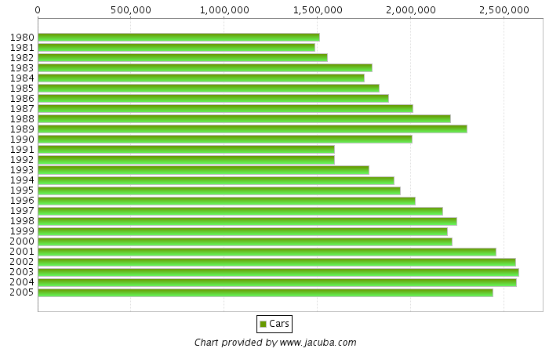

http://www.econstats.com/weo/C171V017.htm
http://www.econstats.com/weo/C171V019.htm

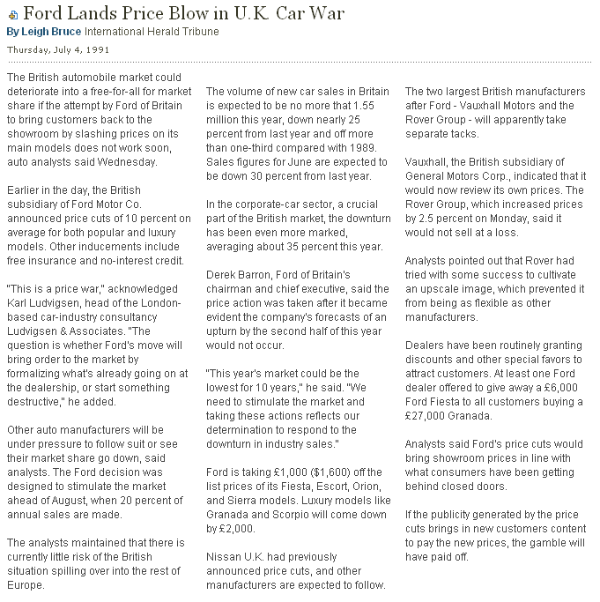
Year | United Kingdom  GDP, current prices  US dollars | Billions | percent change
1980 | 536.66
1981 | 513.06 | -4.4%
1982 | 485.05 | -5.5%
1983 | 459.31 | -5.3%
1984 | 433.52 | -5.6%
1985 | 460.14 | 6.1%
1986 | 559.40 | 21.6%
1987 | 687.73 | 22.9%
1988 | 834.36 | 21.3%
1989 | 843.08 | 1.0%
1990 | 994.62 | 18.0%
1991 | 1036.85 | 4.2%
1992 | 1077.96 | 4.0%
1993 | 963.83 | -10.6%
1994 | 1042.17 | 8.1%
1995 | 1133.94 | 8.8%
1996 | 1191.00 | 5.0%
1997 | 1326.76 | 11.4%
1998 | 1422.22 | 7.2%
1999 | 1461.53 | 2.8%
2000 | 1441.15 | -1.4%
2001 | 1431.77 | -0.7%
2002 | 1567.53 | 9.5%
2003 | 1799.68 | 14.8%
2004 | 2125.51 | 18.1%
2005 | 2295.04 | 8.0%
2006 | 2398.53 | 4.5%
Year | United Kingdom  GDP, constant prices  National currency | Billions | percent change
1980 | 589.75
1981 | 581.25 | -1.4%
1982 | 592.37 | 1.9%
1983 | 613.34 | 3.5%
1984 | 629.11 | 2.6%
1985 | 651.52 | 3.6%
1986 | 677.27 | 4.0%
1987 | 708.12 | 4.6%
1988 | 743.25 | 5.0%
1989 | 759.38 | 2.2%
1990 | 765.14 | 0.8%
1991 | 754.70 | -1.4%
1992 | 756.17 | 0.2%
1993 | 773.80 | 2.3%
1994 | 808.05 | 4.4%
1995 | 831.10 | 2.9%
1996 | 854.52 | 2.8%
1997 | 882.52 | 3.3%
1998 | 909.82 | 3.1%
1999 | 935.82 | 2.9%
2000 | 971.94 | 3.9%
2001 | 994.31 | 2.3%
2002 | 1011.89 | 1.8%
2003 | 1034.10 | 2.2%
2004 | 1066.54 | 3.1%
2005 | 1094.70 | 2.6%
2006 | 1123.09 | 2.6%

http://www.iht.com/articles/1991/07/04/ford.php

Scenario | Price Elasticity | Price Increase % | Change in Sales Reveue for UK Manuf (£ million)
Base Case (no tax) | n/a | 0% | n/a
Inelastic, 30% tax, 30% of tax absorbed by manufacturers | -0.2 | 21% | 168
Inelastic, 30% tax, 15% of tax absorbed by manufacturers | -0.2 | 26% | 175
Less inelastic, 30% tax, 30% of tax absorbed by manufacturers | -0.5 | 21% | 159
Less inelastic, 30% tax, 15% of tax absorbed by manufacturers | -0.5 | 26% | 164
Inelastic, 100% tax, 30% of tax absorbed by manufacturers | -0.2 | 70% | 121
Inelastic, 100% tax,15% of tax absorbed by manufacturers | -0.2 | 85% | 144
Less inelastic, 100% tax, 30% of tax absorbed by manufacturers | -0.5 | 70% | 103
Less inelastic, 100% tax, 15% of tax absorbed by manufacturers | -0.5 | 85% | 120

PESTICIDE DATA

Impact of a 30% tax on each unit of pesticide produced

under different elasticity and incidence assumptions

Source: Department for Environment, Food & Rural Affairs, Design of

a Tax or Charge Scheme for Pesticides, April 2000,

http://www.defra.gov.uk/environment/chemicals/pesticides/pesticidestax/07.htm

NOTE: The above below has been derived from original report by

F. Forsythe UUJ
GENERAL NOTE

Producers of pesticides are legally responsible for paying the tax. The primary users of pesticides are farmers and local councils. Although manufacturers of pesticides are responsible for the tax, they can pass on some of the tax burden to buyers. How much of the tax that can be passed on will depend on the price elasticity of demand. The incidence of tax refers to how the tax burden is shared between producers and buyers.

SEE POWERPOINT PRESENTATION, COMMODITY TAXES, WEBCT

