Learning and Teaching Development Project Final Report

Project: | An investigation into the potential for blended learning approaches in enhancing students’ assessment experience on an Introduction to Economics and Statistics Module.
Author: | Shaista Minhas and Simon Starr
Period covered: | 1 July 2010 to 30 June 2011

Purpose of the report
To report on the final project outcomes, including the main activities of the project and how these may have differed from original plans. Project resources and links to web resources, dissemination details and any evidence of project impact should also be provided. The report should be completed by 30 June 2011.

Main objectives/broad purposes of the project
The overall aim of the project was to assess the potential of blended learning to aid the improvement of the learning process experienced by widening participation students who had been motivated to enrol on a BSc in Business Management Degree Programme at Canterbury Christ Church University, Broadstairs Campus, and were required to take the Introduction to Economics and Statistics Module as part of their first year undergraduate degree programme. “Widening Participation is central to the Mission of the University which is ‘to pursue excellence in academic and professional higher education thereby enriching both individuals and society’. This focus includes a commitment to enabling suitably qualified individuals to access the potential benefits and rewards of higher education and to fulfil their potential whatever their background.” (Canterbury Christ Church University online, 2010, p.4) Part of the widening participation strategy of Canterbury Christ Church University is the development of Broadstairs Campus. This is a satellite campus based in the regionally, economically deprived area of the Isle of Thanet. For the purpose of this project widening participation was defined as a desire “to increase the representation of those groups that are currently under-represented in higher education or in particular aspects of higher education (e.g. males in primary education or nursing). It includes a focus on students and their families from lower-socio-economic groups (NS SEC 4, 5, 6 and 7), from low income groups, those from areas of low participating neighbourhoods, disabled students, students leaving care, part-time and mature students; and some students from minority ethnic communities.” (Canterbury Christ Church University online, 2010, p.1)¹ This is particularly relevant to the regional location of Broadstairs Campus, which is the Isle of Thanet because it would be considered to be a low participating neighbourhood. 12.4% of people living in the Margate District have qualifications at degree level or higher and in the Broadstairs District 16.4% have qualifications at degree level or higher, while in Canterbury, which is only 22 miles from the Isle of Thanet, 28.8% of people have qualifications at degree level or higher. According to Pickvance et al. (p167) “Thanet has a shortage of higher skilled and better paid administrative and technical jobs, because it has few public sector jobs and lacks control functions and even routine office employment.” Thanet District Council (p17) argues that one of their principal aims is to “increase employment opportunities across the business sectors throughout the district.” This provides the context in which to consider whether the economic disequilibrium of the region can, to some extent, be readdressed, and in particular the possible role of the Broadstairs Campus in achieving this by improving learning, teaching and assessment to widening participation students at the site.

The module recruits from a non-traditional student base driven by the University Widening Participation Strategy¹. Given the widening participation context, key challenges are support and guidance (both assessments) and time and travel for with regard to the group assignment. Introduction to Economics and Statistics is a compulsory 20 credit module taken by all first year undergraduate students studying for a BSc in Business Management. The module aims to introduce students to basic statistical techniques which are relevant to the modern day economist. It will also enable students to acquire a knowledge and understanding of the fundamental economic concepts of microeconomics and macroeconomics. The module was assessed by a group essay which discussed the impact of the credit crunch on a region; and an hour time constrained assignment of thirty objective test questions regarding everything studied in the module. Both assessments had a weighting of 50% for the overall performance awarded for the module. Modern economic textbooks: Begg et al. (2008) and Sloman and Hinde (2006) offer blended learning to engage students to obtain a more thorough understanding of the different economic concepts. For the previous cohort 2009/10, the core textbook Begg et al. (2008)⁵ online learning site was chosen to support students with regard to the time constrained assignment.

Three objectives were identified to explore the potential for “blended learning” approaches to enhance the students’ assessment experience, specifically in the areas of guidance and flexibility for the two assessments. Firstly, the introduction of the new blended learning approaches in support of the two module assessments: audio slides (PowerPoint with tutor’s narration) as additional guidance to help students better understand and prepare for both assessments, and WIMBA (a web-based videoconferencing and collaboration system) to enable greater flexibility for the students to engage in the group essay remotely rather than having to travel. The second objective was designed to evaluate the impact of the introduction of the two new approaches on the assessment performance and group dynamics and cohesiveness between 2009/10 and 2010/11 cohorts. Finally, the evaluation of 2010/11 cohort students’ perceptions, attitudes and satisfaction towards new and existing approaches with regard to the introduction of audio slides and WIMBA, and the continuation of open access to online test questions and feedback provided by the publisher of a key Economics text⁵ for the time constrained assignment.

The project investigated enhancing support for assessment as part of students’ wider learning experience. Two new forms of blended learning: Audio slides and WIMBA were introduced to the cohort of 2010/11 with the desire to encourage active learning. Audio slides are self-contained files which include visual aids (or slides) with a recording of tutors’ voice made using computer headset with a microphone. There are numerous software applications to make audio slides ranging in functionality from PowerPoint’s ‘Record Narration’ feature to Captivate which can import PowerPoint slides to home-grown systems such as University of Hertfordshire’s SMIRK. Audio slides literature in Higher Education focuses on delivery rather than support for assessment. Suggested benefits include engaging students and promoting deeper study. In a case study for the Economics Network, Kraithman and Bennett described students using audio slides being more “primed and active” in seminars on a first year Microeconomics module. Lorimer and Hilliard find students spend 75-100% more time studying course content through audio slides when compared with lectures. The Higher Education Academy IMPALA project finds students value use of audio slides for revision. This research investigated whether these benefits to delivery could also be applied to the support for coursework. Also, web-based videoconferencing and collaboration systems enable the tutor and students to come together at a distance, in real-time, over the Internet using a normal PC rather than going to a physical room equipped for videoconferencing. Use of videoconferencing is new to the University. WIMBA was being piloted during 2010-11. Students previously scheduled face to face meetings to work on the group essay assignment. Using WIMBA, they may be “connected to a community of learners anytime and anywhere, without being time, place or situation bound” as described by Garrison and Kanuka, thus reduce travel time and costs and enabling a better work-life-study balance. A key module skill is “the capacity to communicate knowledge in an appropriate manner to a range of audiences”. The introduction of videoconferencing may also give the groups another dimension to help reinforce and complement their skills of communicating and managing a team that could be transferred to the working environment. Notably, this link between online University study and employability is made explicit in the Government’s Higher Ambitions paper. The potential for videoconferencing in education has been discussed for many years. In evaluating their ‘Video Conferencing in the Classroom’ project, Becta (2004) found “clear evidence of the educational potential of videoconferencing facilitating a broad range of personal, social and academic benefits for pupils”. In a literature review, De Freitas & Neumann (2009) identify a wide range of tools and pedagogic models for videoconferencing. Martin (2005), relating experience of videoconferencing in schools and Higher Education, suggests it can help to “dissolve boundaries in the mind and externally”, highlighting research that “for distance learning applications... [videoconferencing] appears to be as effective as face-to-face contact” (Leask & Pachler in Martin, 2005). In undertaking a Higher Education Academy pathfinder project on exploring the use of videoconferencing in teaching and learning Exeter University (2008) found “students see the value of teaching via VC and perceive that it allows them access to specialist teaching that they would not otherwise receive”.

With increasing availability of web-based videoconferencing systems, however, the rooms have become virtual rather than physical, tutors and students can access them using their own PC rather than travelling and the costs are much reduced. Use is growing of two such systems – Elluminate Live! and WIMBA Classroom. Both are designed primarily for use in education and each offer case studies from Higher Education. Use of videoconferencing at University of Hertfordshire suggests that "… students are actually more confident about contributing online than in the face-to-face classroom, and the virtual classroom environment makes teachers think about how to increase interactivity and reinforces good teaching practices." (elluminate.com). Use at York St John University enables “opportunities for meetings without boundaries, and to ask rich, insightful and challenging questions in a ‘safe’ environment, gain direct feedback, and to follow up with archiving for revision and later access” (wimba.com).

Main activities of the project (and how and why these may have differed from original plans)
The first activity was the actual production of the audio slides during September/October 2010 to provide guidance and support for both assignments. The audio slides were made available to all the students through Blackboard VLE from the beginning of the module on 1st October 2010. Microsoft PowerPoint 2007 was used with the ‘Record Narration’ feature to create the audio slides. This enabled the tutor to voice over pre-prepared slides using a computer headset in ‘Slide Show’ mode, clicking to build points and animations to control the flow of the presentation in the normal way. The tutor’s narration and slide timings are recorded in the PowerPoint file itself which is uploaded for students to access via the University’s Blackboard VLE. Students download and open the PowerPoint in Slide Show Mode to play back.

The advantage of using PowerPoint was that it was familiar to both the tutor and the students. Therefore, it could be argued that training for both staff and students was at a minimum and no additional software needed to be installed at the university. However, a limitation was that there was little in-presentation control beyond moving from the next slide or the previous whole slide. There was no pause or rewind option during a slide and no simple way of navigating the presentation out of sequence.

Support to enable the tutor to produce the audio slides was relatively straightforward. The University’s Computing Services department procured and installed a headset on the tutor’s PC and the Faculty Learning Technologist provided training for an hour on PowerPoint Narration. This worked fairly well although there were some problems. The original headset installed did not record. This was the type plugged into the PC microphone socket. There were multiple sockets and they needed switching on and recording levels setting before use. This was highly technical and not intuitive at all. To address this, a USB headset was procured instead. This was ‘plug and play’ and was much more intuitive to use. There was something of a ‘hiss’ on the recording of the tutor’s voice. This was related to the recording quality settings in PowerPoint which can be set low to enable a smaller file size

The second activity related to WIMBA, the Web-based Videoconferencing and Collaboration System. WIMBA is a web-based system linked to the University’s Blackboard VLE. A demonstration of WIMBA was pre-recorded by the tutor and the Faculty Learning Technologist. This was made available to the students via the University’s Blackboard VLE from October 2010. In December 2010, the opportunity was given to any student to have a training session for WIMBA in an Apple Mac seminar room, as all the students had been given an Apple Mac account. No student attended the training. Some students stated they were too busy working on other assignment work for different modules. In February 2011, three groups requested the opportunity to use a separate WIMBA room within the Blackboard VLE for each of the student groups after an open WIMBA room was created for students to try it out and a live demonstration and question and answer session provided by the Learning Technologist. There was a challenge in that WIMBA was being piloted in the University at the time and there was no formal on-campus support. Although primarily designed for a tutor to facilitate sessions, students were given ‘instructor’ privileges to be able to enable them to present and annotate slides and visit web sites together. A WIMBA Classroom was used to provide online videoconferencing and collaboration ‘rooms’ for the student groups.

Support for the tutor was provided by the University’s Computing Services Department, whom procured and installed a web cam on the tutor’s PC. Their network access to WIMBA was tested for a known ‘Java’ software update issue. This was resolved easily. The Faculty Learning Technologist provided around 2 hours training for the tutor online, via WIMBA itself. Training was ongoing through use of WIMBA to conduct project progress meetings.

Support for the student groups opting to use WIMBA for their group essay was challenging. The way in which WIMBA integrates with the Blackboard VLE meant that, although a room for each student group was created, any student could access any room. Privacy for each group of students was essential and so a way of restricting access had to be found. Without the tutor present, this proved complicated. The option of restricting access by using the Blackboard VLE’s in-built permissions, ‘hiding’ the rooms to all but the students in the relevant group was considered. To some degree this was successful, and links to each room were hidden. However, there was a ‘back door,’ which could not be disabled and identified a list of all the rooms. The only alternative was to set up group rooms directly on the WIMBA system, outside of Blackboard altogether, with separate logins for students. This proved very complex and time-consuming.

The two activities discussed regarding the production of the audio slides and the availability of WIMBA (a web-based videoconferencing and collaboration system) covered the first objective with regard to the introduction of the new blended learning approaches in support of the two module assessments. The third activity focused on the second and third objectives which were designed to evaluate the impact of the introduction of the two new approaches on the assessment performance and group dynamics and cohesiveness between 2009/10 and 2010/11 cohorts, and the evaluation of 2010/11 cohort students’ perceptions, attitudes and satisfaction towards the new and existing approaches with regard to the introduction of audio slides and WIMBA and the continuation of the online test questions. Therefore, the third activity evaluated the impact of new and existing blended learning approaches in support of the assessments by comparing cohort assessment performances and by surveying students. There were 42 students in the 2009/10 cohort and 45 students in the 2010/11 cohort who studied the Introduction to Economics and Statistics Module. The methodology applied was a combination of quantitative and qualitative data gathered. The quantitative data was gathered from surveys completed by both cohorts, mapping of the movement of the group dynamics in each year, and the performance of the two cohorts through the assessments. Qualitative data was determined through interviews with students during seminar activities and individual tutorials. In order to make a valid comparison of the performance, both assessments were identical for the two cohorts.

Outcomes of the project
It was argued that the quality of the production of the audio slides could be improved at the cost of a larger file. Therefore the scope for investigating the balance between sound quality and file size needed to be evaluated in the future. The overall attitude and opinions of the 2010/11 cohort were positive with regard to audio slides. Also, both cohorts agreed that the online test questions and feedback provided support for the time constrained assignment. However, the research highlighted that it could not be argued that audio slides replaced face to face guidance for assessment preparation by recording guidance in audio slides. Instead, the research suggested that audio slides complemented tutorials as discussion could be focused around the audio slides rather than replacing tutor-led support for both assignments. Also, the Higher Education Academy IMPALA¹² project found students valued the use of audio slides for revision. The opinions of the 2010/11 cohort agreed with this Project’s¹² findings. However a comparison of marks between the 2009/10 cohort and the 2010/11 cohort identified there was no actual variation of marks. (See Table 1) Also the chi-squared statistically demonstrated there was no deviation of the degree award categories between the two cohorts with regard to the time constrained assignment. (See Chart: Performance for TCA and Appendix 1) Thus it could be argued that the 2010/11 cohort only perceived audio slides and online test questions did improve the learning process they experienced, but the new blended learning approach did not impact on the actual marks they achieved compared to the 2009/10 cohort.

Table 1: Time Constrained Assignment (TCA)
Cohort | TCA
2009/10 Average | 61.79
2009/10 Standard Deviation | 16.19
2010/11 Average | 61.78
2010/11 Standard Deviation | 15.82

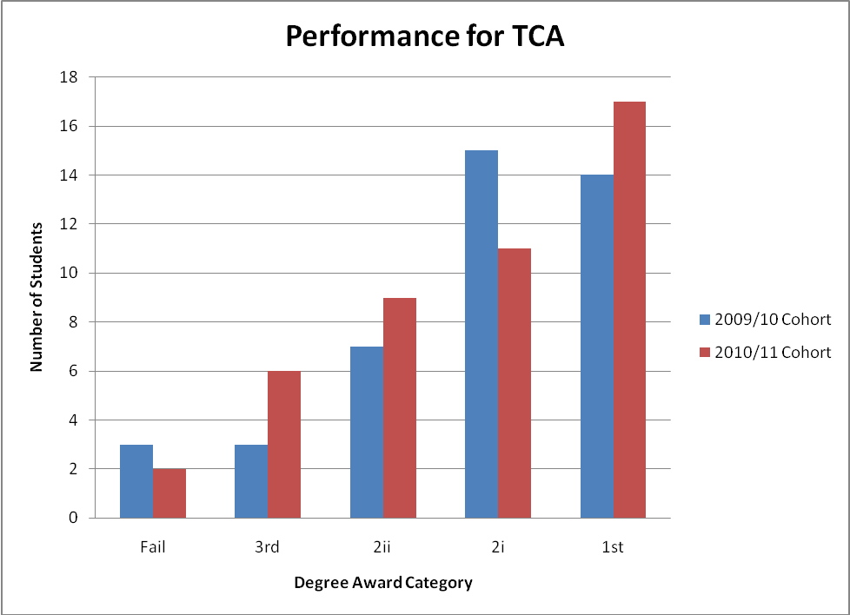

The implementation of WIMBA (a web-based videoconferencing and collaboration system) proved very complex and time-consuming, even though only three groups had originally signed up to use WIMBA. It could be argued that the strength of integrating WIMBA with Blackboard VLE is in needing only a Blackboard login and not having to learn how to login to a new system on a different web site. However, without a facility through Blackboard VLE to create private, student-led group rooms this approach is impractical. There was initial interest in using WIMBA by three groups for the group essay. However, none of the 3 groups actually followed through and used WIMBA, because they had not chosen to attend the training session offered in December 2010. Thus this resulted in the students not effectively using WIMBA. The students stated they were unable to properly access the group WIMBA classroom for collaborative assignment work. It could be argued that the research illustrated that WIMBA is not designed for student-led use in group assessment work. None of the ten groups for the 2010/11 cohort requested a tutorial with the tutor using WIMBA; instead they preferred a face-to-face tutorial where group members and the tutor were present. The research highlighted that 70% of students for the 2010/11 cohort stated they preferred to communicate in person. Some students stated that communicating on a mobile phone that had a web camera was sufficient with regard to encouraging the production of a group essay. Also for the 2010/11 cohort, some students identified that they preferred to use social network websites like Facebook or Skype to communicate with their colleagues because no prior training was required. However 88% of the same students stated they would consider using WIMBA in the future.

The research also identified that the team management skills of the 2010/11 cohort were significantly less focused on planning than their predecessors students from the 2009/10 cohort. Mapping the movement of the students between groups for the 2009/10 cohort identified that no student changed groups after the beginning of the Lent Term. However, 25% of the students had not formally identified they were in a group at the beginning of the Lent Term, and on the day the group essay was scheduled to be handed in at the end of the Lent term, a student changed groups, with regard to the 2010/11 cohort. Also there were only 10 groups in the 2010/11 cohort, which meant on average each group had 4.5 students; while there were 14 groups in the 2009/10 cohort, which meant on average each group had 3 students. Therefore, it could be argued that the groups for the 2010/11 cohort needed to communicate in person to ensure greater understanding of the construction of the group essay because they had chosen not to organise themselves at an earlier stage of the academic year and were required to communicate with a larger number of students than the previous cohort. A comparison of the assessment performance of the 2010/11 cohort to the 2009/10 cohort with regard to the group essay demonstrated a significant variation of marks awarded with regard to the average mark, which varied by 14.67%, and the standard deviation, which varied by 4.21%. (See Table 2) The chi- squared statistically demonstrated there was a deviation of the degree award categories between the two cohorts with regard to the group essay assignment (See Chart: Performance for Group Essay and Appendix 2). Thus, it could be argued that the research identified the students for 2010/11 cohort needed to further develop their management skills before being able to successfully apply WIMBA, but they appreciated the potential of the new blended learning approach.

Table 2: Group Essay
Cohort | Essay
2009/10 Average | 58.00
2009/10 Standard Deviation | 16.08
2010/11 Average | 43.33
2010/11 Standard Deviation | 11.87

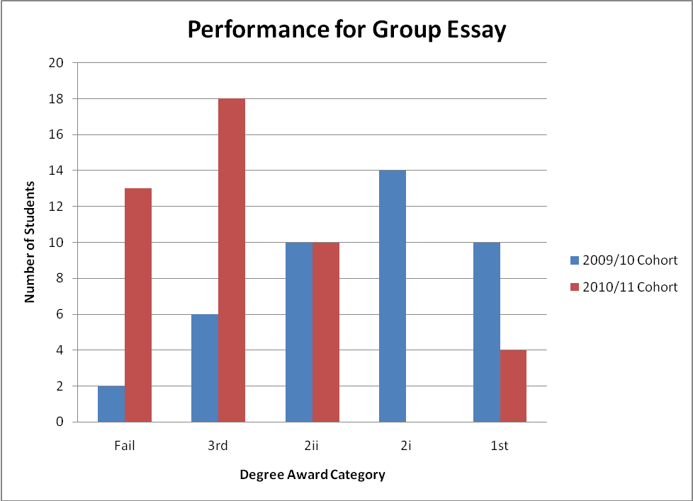

A comparison of the overall average marks and the respective overall standard deviations for the module showed that for the 2009/10 cohort their average mark was 7.33% higher than for the 2010/11 cohort, while the standard deviation variation was 5.70% marks less for the 2010/11 cohort than the 2009/10 cohort.(See table 3) Thus the 2009/10 cohort’s overall performance for the module was higher than the overall performance for the 2010/11 cohort (see Chart: Overall Performance of the Module), but the same number of students i.e. two failed in both cohorts. Also, the Pearson’s Product Moment Correlation Coefficient for the 2009/10 cohort was a positive 56% correlation, which was significantly higher than the correlation for the 2010/11 cohort which was only a weak positive 20% correlation. Therefore, it could be argued that the performance of the students in the 2009/10 cohort for the two assessments had a higher degree of determining similar marks for the time constrained assignment and the group essay, than the students’ performance for the 2010/11 cohort.

Table 3: Marks for the Module
Cohort | Overall
2009/10 Average | 59.89
2009/10 Standard Deviation | 14.26
2010/11 Average | 52.56
2010/11 Standard Deviation | 10.78

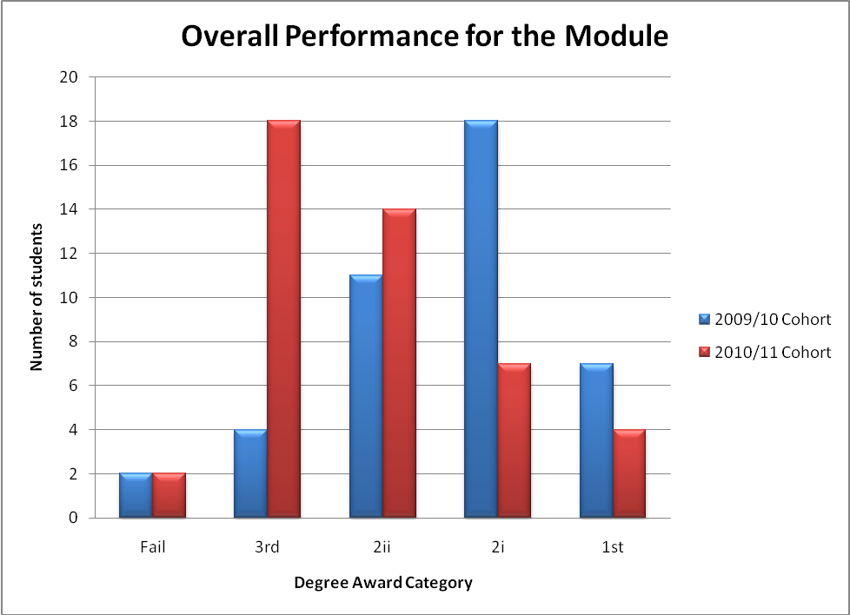

Thus, overall it could be argued that the research identified that 2010/11 cohort perceived that audio slides did make a positive contribution to their understanding of the module. However, this perception was not reflected in their overall grades, which on average were 7.33% lower than the 2009/10 cohort. Also, the students stated a preference for face –to-face communication with regard to the group essay. Those students who did use online forms of communication in their groups preferred to apply familiar external technologies i.e. a mobile phone and Facebook. However, a more structured tutor-led WIMBA would be considered by the students in their future studies. Thus, it could be argued that there was no overall quantifiable impact of the new blended learning approaches to the actual performance for the 2010/11 cohort with regard to the two assessments. However, the students’ perceptions of the new blended learning approaches were positive and therefore could be argued to have enhanced the students’ assessment experience.

Available resources (including web links)

Audio slides for both assignments and demo WIMBA at:
https://blackboard.canterbury.ac.uk/webapps/lobj-wiki-bb_bb60/wiki/CC10MinhasStarrENProject/_680342_1/Home

Case study published in the Economics Network Newsletter: Issue 17: Summer 2011
http://www.economicsnetwork.ac.uk/newsletter/economics_news17.pdf

Dissemination (details of events, dates etc disseminated and planned)

A case study published in the Economics Network Newsletter: Issue 17: Summer 2011

A half day regional workshop on 29th June 2011 at the University’s Broadstairs Campus. Simon Starr and Shaista Minhas presented the findings, made links with pilot studies of audio slides and Wimba across other University departments and offered hands-on “taster” activities using audio slides and Wimba. Also, recorded and made available to the Economics Network and JISC regional network with which Canterbury Christ Church University has close contact with. The workshop invited colleagues from:
- Canterbury Christ Church University staff
- members of JISC South East Regional Support Centre network
- members of Economics Network

Simon Starr and Shaista Minhas will be presenting our findings at the Developments in Economics Education Conference 2011 on 5th September 2011

Impact (please include any evaluation data or any other evidence of the project’s impact)
The Project has contributed to an increased interest in using audio slides within the Faculty of Business and Management as well as across the wider University. As one of a wide range of Faculty Technology Enhanced Learning (TEL) pilots, evaluation of the Project has also contributed directly to the development of the Faculty’s TEL strategy to guide future programme development and delivery. Partly as a result of this Project, central learning technology support is now provided for audio slides to aid support and flexibility of learning at Canterbury Christ Church University. USB is now the standard for new headsets for all University departments in order to maintain quality of audio slides.
Through participation in a University-wide pilot of the WIMBA videoconferencing and collaboration system, evaluation of the Project has contributed to a central University commitment to continue with WIMBA in support of its strategic plan.
The regional workshop encouraged the dissemination of knowledge and experience obtained through the research regarding the investigation into the potential for blended learning approaches in enhancing students’ assessment experience on an Introduction to Economics and Statistics Module. The workshop was originally aimed primarily at facilitators of learning and was open to the Economics Network members, JISC RSC South-East members and colleagues from Canterbury Christ Church University. However, only internal staff were able to attend the regional workshop and this lead to further discussion and awareness regarding the involvement of blended learning approaches to different departments at Canterbury Christ Church University. The plenary identified that staff would be taking ideas for developing learning and teaching back to their respective departments.

Appendix 1: Chi-squared for TCA

Table: Time constrained assignment
Degree Awards Categories | Fail | 3rd | 2ii | 2i | 1st
2009/10 Cohort | 3 | 3 | 7 | 15 | 14
2010/11 Cohort | 2 | 6 | 9 | 11 | 17

H0: There is no association between the cohort and the degree award categories
H1: There is an association between the cohort and the degree award categories

Chi-squared statistic was 2.25494
With 4 degrees of freedom the critical value is 9.488

2.25494 is less than 9.488.
Therefore accept H0. There is no statistical association between the cohort and the degree award categories for the time constrained assignment.

Appendix 2: Chi-squared for Group Essay

Table: Group Essay Assignment
Degree Awards Categories | Fail | 3rd | 2ii | 2i | 1st
2009/10 Cohort | 2 | 6 | 10 | 14 | 10
2010/11 Cohort | 13 | 18 | 10 | 0 | 4

H0: There is no association between the cohorts and the degree award categories
H1: There is an association between the cohorts and the degree award categories

Chi-squared statistic was 30.571
With 4 degrees of freedom the critical value is 9.488

30.572 is greater than 9.488
Therefore reject H0 and accept H1. There is a statistical association between the cohort and the degree award categories for the group essay.

Canterbury Christ Church University Widening Participation Strategic Assessment 2009 -2012. Available at: http://www.canterbury.ac.uk/support/partnerships-widening-participation/documents.asp (Accessed: 22 Mar 2010)
Office for National Statistics. Available at: http://www.statistics.gov.uk (Accessed: 22 Mar 2010)
Pickvance, C., Harloe, M., and Urry, J. (Ed) (1990) Place Policy and Politics Do Localities Matter? Unwin Hyman, London
Thanet District Council Economic Development Business Plans 2002/3 & 2003/4
Begg, D., Fischer, S. And Dornbusch, R. (2008) Economics McGraw Hill
Sloman, J. and Hinde, K. (2006) Economics for Business Prentice Hall
See: http://office.microsoft.com/en-us/powerpoint-help/add-narration-to-a-presentation-HA001230306.aspx?CTT=1 (Accessed: 9 May 2011)
See: http://help.adobe.com/en_US/Captivate/4.0/Using/WS5b3ccc516d4fbf351e63e3d119e9582981-7fe4.html (Accessed: 9 May 2011)
See: http://sitem.herts.ac.uk/smirk/ (Accessed: 9 May 2011)
Kraithman, D., Bennett, S. (2005) Blending Chalk, Talk and Accessibility in an Introductory Economics Module. Higher Education Academy Economics Network. Available at: http://www.economicsnetwork.ac.uk/showcase/kraithman_smirk.htm (Accessed: 9 May 2011)
Lorimer, J., Hilliard, A. (2009) ‘Incorporating learning technologies into undergraduate radiography education’, Radiography, 15(3), pp. 214-219
HEA IMPALA Project - The Use of Podcast to Provide Lecture Recordings (2007). Available at: http://www.impala.ac.uk/outputs/examplars/ (Accessed: 9 May 2011)
13 Garrison, R., Kanuka, H. (2004) ‘Blended learning: Uncovering its transformative potential in higher education’, Internet and Higher Education, 7, pp. 95-105
¹⁴ BIS (2009). ‘Higher Ambitions – The future of universities in a knowledge economy’. Available at: http://www.bis.gov.uk/policies/higher-ambitions (Accessed: 16 Feb 2010)
Becta. (2004) ‘Evaluation for the DfES Video Conferencing in the Classroom project Final Report’. Becta. Available at http://ww.global-leap.org%2Fabout%2Fvideo_conferencing_final_report_may04.pdf (Accessed: 9 May 2011)
De Freitas, S. & Neumann, T. (2009) ‘Pedagogic strategies supporting the use of Synchronous Audiographic Conferencing: A review of the literature’, British Journal of Educational Technology, 6, pp. 980-998
Martin, M. (2005) ‘Seeing is believing: the role of videoconferencing in distance learning’, British Journal of Educational Technology, 7, pp. 95-105
Exeter University Pathfinder Project: Using video and conferencing technologies for teaching and learning. Higher Education Academy web site. Available at: http://www.heacademy.ac.uk/projects/detail/learningandtechnology/Pathfinder/Briefing_Papers/University_of_Exeter (Accessed: 10 May 2011). Project blog: http://www.services.ec.ac.uk/edu/vcproject JUNE 2008 Briefing Paper 1: Rationale, research design and recommendations
http://www.elluminate.com/Products/Elluminate_Learning_Suite/Elluminate_Live!/?id=79 (Accessed: 9 May 2011)
See: http://www.wimba.com/products/wimba_classroom/ (Accessed: 9 May 2011)
Elluminate. Case studies. Available at: http://www.elluminate.com/Resources/Case_Studies/Detail/21/?id=218 (Accessed: 9 May 2011)
Wimba. Customer spot lights. Available at http://www.wimba.com/customers/customer-spotlights/york_st_john_university (Accessed: 9 May 2011)

