Econ net mini proj final 06-07

Mini-Project Final Report

Mini-Project: | An Investigation into the Application of Economics Threshold Concepts using WinEcon via a VLE for Business Students
Author: | M Walsh, Dr K Gray
Period covered: | 1 August 2006 to 31 July 2007

Main objectives/broad purposes of the project

WinEcon is extensively used at Coventry University, particularly on business degrees where it is the main, although not exclusive, method of delivering the workshop programme. Our experience from teaching an introductory economics course designed for business students is that students find certain threshold concepts relatively difficult, particularly opportunity cost, marginal analysis, and cumulative causation (the multiplier). Given this, we decided to address this problem by applying Economics Threshold Concepts using WinEcon via WebCT. This mini-project draws from two Fund for the Development of Teaching and Learning 5 projects (FDTL5);
- Embedding threshold concepts in first year undergraduate economics
- Beyond dissemination strategies: Embedding computer based learning and effective use of WinEcon and VLEs.

The project aims were to; (a) investigate feasibility of embedding selected threshold concepts using WinEcon via a VLE for business students,(b) develop relevant teaching materials, (c) assess how students’ understanding of these concepts changes as a result of embedding, and (d) investigate possibility of embedding a wider range of threshold concepts.

Main activities of the project (and how and why these may have differed from original plans)

There were two research groups, one full time day group and one part time evening group, plus a control group, which was a full time day group. These groups represented approximately one third of the students on the module. Each threshold concept was addressed in a four stage process, which is outlined below with respect to opportunity cost.

Stage I (week 2 for opportunity cost) involved the introduction of a threshold concept during lectures, while in Stage II (week4) baseline questions were issued (see available resources, handout A) to assess students’ initial understanding and application of the concept. The questions are concise so as not to lose students’ interest, and to enable them to be completed in workshop time. It was considered better for students to complete this project work in class rather than in their own time to ensure completion. In Stage III (week 8) all three groups undertook a short case study considering the opportunity cost of examination revision (handout B), and in addition the research groups undertook a WinEcon activity (handout C). The control group did replacement work for handout C (handout D). Finally, in Stage IV (week 9 for opportunity cost) the groups were given the baseline questions again in order to assess their understanding and application. Relevant material (handouts E – H) for the multiplier can be found under available resources.

The activities of the project differed in some respects from our original plan. Firstly, we encountered problems making the hyperlinks to the relevant topics in WinEcon work, which were rectified towards the end of the year, and therefore students used the WinEcon menu. We were also reticent about putting worksheets on WebCT due to possible low attendance, and so, given the problems with hyperlinks, our dilemma was solved and we decided only to issue these during workshops. Despite this there were non-attendance problems regarding the multiplier concept as it was towards the end of the course when students had many coursework deadlines, which resulted in lower numbers of students who did both the baseline and follow up questions. Secondly, there was insufficient workshop time to include marginal analysis as part of the project due to a reduction in workshop hours following modification of the degree structure.

There were implementation issues in addition to those above. We felt that the part time evening students (research group 2) were more motivated, regarding results and attendance. It is also worth reflecting whether student motivation, and the results, may have differed if the baseline questions were part of a summative assessment. There were some unanticipated benefits, particularly the move from an unrealistic WinEcon pricing structure which allowed downloading to individual (registered) business students, which was pioneered at Coventry University.

Instructions on inserting hyperlinks on handouts can be found on www.winecon.com, with informative short video clips illustrating how web-links are used and how to create them.

http://www.winecon.com/video/using_weblinks/

http://www.winecon.com/video/creating_weblinks/

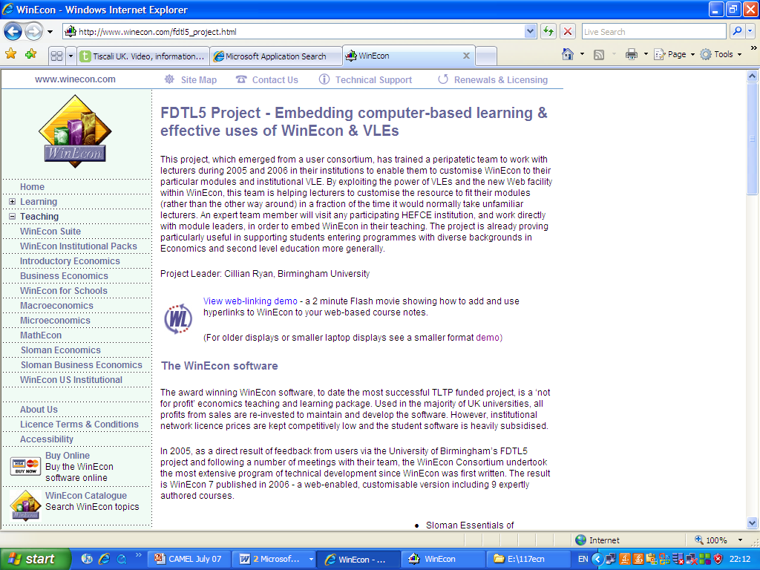

Outcomes of the project
Students’ understanding and application of threshold concepts was uncertain from our study, although this conclusion is based on relatively low student numbers. Low student numbers were largely due to low attendance in certain workshops, making it difficult to match pre-activity and post-activity questions for a threshold concept in sufficient numbers. Regarding opportunity cost, students were asked their perceived understanding (table1), to select a correct definition (table 2), and select an application (table3). Comparison of correct answers before and after the WinEcon input did not give a clear picture for research groups relative to the control groups, although the second research group tended to be strongest. Could this be due to the fact that this was the part-time group where students are older, have greater experience, and possibly greater motivation. The results for the multiplier (tables 4 to 6) again do not give clear results regarding the impact of using WinEcon, although much small numbers make it difficult to interpret. However, two points seem to emerge. Firstly, there was much lower confidence regarding the multiplier (particularly before the WinEcon input) relative to opportunity cost, which was a surprising to the tutors. Secondly, the part-time group was again stronger.

We would suggest that it is feasible to embed threshold concepts using WinEcon. Although the hyperlinks did not initially work, these were working towards the end of the project when used on a revision sheet. Therefore we feel this could be extended to further threshold concepts. Despite the results not being conclusive, a WinEcon survey in May 2007 (see appendix for results) of Coventry University business students indicated students found WinEcon a useful learning aid, 74% rated WinEcon as excellent/good, 87% would want WinEcon if they did another economics course, and 73% found links very easy / easy to use. In addition, the results indicate students are now accessing WinEcon outside the lab, which did not previously happen, partly due to a more realistic WinEcon pricing structure for individual users, which was pioneered at Coventry University. This again supports the feasibility of using WinEcon.

In conclusion, although the results were of students’ understanding were not clear, we feel that it is feasible to embed threshold concepts using WinEcon and that students find WinEcon a useful resource. Study material and processes have been developed which may provide a foundation for further work in this area.

Available resources – see following pages

HANDOUT A

Threshold Concepts and WinEcon for First Year Business Undergraduates

Opportunity cost

Please answer the following questions by circling the appropriate answer.

1. Do you understand what is meant by opportunity cost?

Please circle the appropriate number.

1 | 2 | 3 | 4 | 5

Uncertain Certain

2. Which is the following is a definition of opportunity cost?

- The change in total cost from producing one more unit of a good.

- The cost of any decision measured in terms of the best alternative forgone.

c) Costs that vary with the amount of output produced.

3. Which of the following best illustrates the application of opportunity cost to business?

- An entrepreneur spends £500,000 on equipment and premises for a restaurant, even
before opening up to customers and cooking meals.

- Henry Ford reduced the cost to make each car through implementing mass production.

- A firm’s decision to spend £20m on an advertising campaign means it has to sacrifice
spending on research and development.

Name:_________________________________________________

Note: this is not part of your assessed coursework.

HANDOUT B
Winecon/thresholds project
Opportunity Cost

“Relax or Revise? Solving an Age Old Student Dilemma”¹

Many students leave their revision too late, preferring the ‘just – in – time’ approach to time management. If you are a believer in this approach, an understanding of opportunity cost might change your ways for the better.
Near the exam date for 117ECN you might estimate that the benefit gained from reading your economics textbook is £10 per hour whilst the benefit of being on MSN (an internet site) talking to friends is £5 per hour. If you revise from the textbook, then the cost of the next best alternative foregone, i.e. the opportunity cost, is £5. Given this ratio of £10 of benefit from reading the textbook set against £5 in respect of giving up chatting to friends on MSN, you can minimise your opportunity costs by revising from the textbook.
However, a month before your exam for 117ECN you might value the benefits of talking to friends on MSN at £20 per hour and the benefits of reading your economics textbook at £5 per hour. If you now choose to revise from the textbook, the opportunity cost would be £20 whilst going on MSN would represent an opportunity cost of only £5. So in terms of opportunity cost it is cheaper for you to go on MSN than read your economics textbook. Of course, if you subsequently fail the exam for 117ECN by choosing to revise at the last minute, at least you will understand why you have failed!

1. Adapted from Begg, D. & Ward, D., Economics for Business, p. 7, (2003), McGwaw-Hill.

Questions:

- Why might an understanding of opportunity cost improve the likelihood that a student will pass the exam for 117ECN?
- Why is it rational for a student to weigh up the benefits and costs associated with different ways of spending their time?

HANDOUT C
Winecon/thresholds project
CH.1 What is Economics?

Introduction
After covering the basic economic problem in the lecture we are now going to reinforce these ideas by working through part of chapter 1 of Winecon. You do not need to work through all of chapter 1, but only the relevant sections that are identified below in order to answer the questions on this sheet.

Section number: 1.1 Introduction to economics & Objectives and actions: Allocating a health budget

1. After working through the 'Allocating a health budget' activity to initially save a total of 356 lives (the maximum possible given the budget), fill in the spaces below.

Disease A B C

% of budget spent on each disease
in order to maximise the total number of
lives saved: _ _ _

Lives saved for each disease _ _ _

What is your budget? £____________

How much do you spend on each disease? A £______

B £______

C £______
Which patients lose out?______

- Explain how the concept of opportunity cost is relevant in question 1.

_____________________________________________________________________________________________________________________________________________________________________________________________________________________________________________________________________________________________________________________________________________________________________________________________________________________________________________________________________________________________________________________________________________

- As you work through the activity the price of treating disease C falls. What is the effect on treatment for patients with diseases A, B and C?

What is the change in the price of treating disease C as you work through the activity?___________

Following a fall in the price of treating disease C fill in the spaces below.

Disease A B C

% of budget spent on each disease
in order to maximise the total number of
lives saved: _ _ _

Lives saved for each disease _ _ _

Total number of lives saved?________

How much do you now spend on each disease?
(note: your total budget is unchanged) A £______

B £______

C £______

4. Is opportunity cost relevant to question 3? Yes / No
(circle your response)
Give a reason for your answer.

HANDOUT D

WinEcon/thresholds Project

Opportunity Cost

WinEcon alternative

The following problem is designed to help you apply the principle of opportunity cost to the real world.

The city of Coventry owns a run-down and part-derelict piece of parkland in the city centre. Coventry’s mayor has proposed converting the land into a theme park. The mayor proposes partly paying for the theme park’s development by introducing a tax on people staying in hotels in the Coventry area. She argues that Coventrians should support the project given visitors will help pay for it.

Questions:

- Use the concept of opportunity cost to give a response to the mayor’s proposal.

- How would an understanding of the concept of opportunity cost help potential overnight visitors to Coventry make their decisions on whether to stay in hotels in other nearby towns?

HANDOUT E

Threshold Concepts and Winecon for First Year Business Undergraduates

The Multiplier

Please answer the following questions by circling the appropriate answer.

1. Do you understand what the multiplier means?

Please circle the appropriate number.

1 | 2 | 3 | 4 | 5

Uncertain Certain

2. Which of the following statements best defines the multiplier?

- Investment depends upon the rate of change of national income.
- It is the percentage by which consumption increases following an increase in income.
c) It describes the fact that a change in spending has an impact on national income that is greater than the original change in spending.

3. Which of the following best illustrates the application of the multiplier to business?

- If the UK economy grew more quickly this would encourage an increase in investment by business.
- Overall, the Irish economy was expected to benefit to the tune of 130m Euros from hosting the Ryder Cup in September 2006, resulting from a smaller initial injection.
- The UK avoided recession in 2001 as consumption, a major component of aggregate demand, remained buoyant.
,

Name:_________________________________________________
Note: this is not part of your assessed coursework.

HANDOUT F

WinEcon/thresholds project
Local Multiplier Analysis

Local Multiplier Analysis

“University’s Major Contribution to the Local Economy”

Coventry University has a major impact on the Coventry economy. In 2005, the University’s presence added around £100m to local output – about 1.5% of local GDP. Figures also suggest that the University added around £61m to local disposable income. In addition to the 2000 workers directly employed by the University, around a further 500 full –time equivalent jobs are generated indirectly by the University.

In addition to the direct expenditure and jobs created by Coventry University, the University has a strong track record of bringing former derelict land and buildings back into economic use. Examples would include the 20 acre Technology Park on the former Rolls-Royce Parkside site; the Singer Hall student Village; the William Morris Building on Gosford Street; the £3m Enterprise Centre for small and medium sized enterprise development and the recent £4m Sports and Recreation Centre.

It is through staff wages that the University makes the biggest contribution to the local economy with 90% of non – teaching staff and around 70% of teaching staff living in the Coventry – Warwickshire area, spending around £12m (or 50%) of their disposable income locally.

The second main route through which the University’s expenditure benefits the local economy is the purchase of goods and services by the University and Students’ Union. These purchases amount to roughly £24m of which around 30% were purchases from local businesses.

Last but not least, the spending power of the students is the third way the University contributes to the local economy, with around 84% of their outgoings being spent locally.

The value of student’s spending power was calculated in two ways. The first calculation excluded students who normally live in the Coventry – Warwickshire area, the argument being that their expenditure does not represent additional income for the area concerned. Using this criterion, it was estimated that full-time students spent £32m during term time. In the second calculation, local students were included, as, but for the presence of the University, they may have left the local economy to study elsewhere. This produced the equivalent figure of £41m.

Using the figure of around 84% of outgoings being spent locally produced figures of £27m and £34m respectively flowing into the local economy as a result of Coventry University student’s expenditure.

Questions:

- Explain the concept of the multiplier using a simple numerical example. What happens to the value of the multiplier you have calculated if the marginal propensity to save increases?
- How does the multiplier process help explain the importance of the University to the Coventry local economy?
- At the national level, why would an understanding of the multiplier be useful to Gordon Brown (currently the UK Government’s Chancellor of the Exchequer)?

HANDOUT G

Winecon/thresholds project
Ch. 11
Circular Flow Model of the Economy

Introduction
After covering the basics of this topic in the lecture we are now going to reinforce this ideas by working through part of chapter 11 of Winecon. You do not need to work through all of chapter 11, but only the relevant sections that are identified below in order to answer the questions on this sheet.

Section number: 11.2 Circular flow of income and expenditure
Topic: Basic concepts: firms and households
Topic: Basic concepts: aggregate markets

1. Draw a diagram (on p.2) showing and explaining the following flows between households and firms:

*consumer expenditure or consumption (C)
*goods and services
*factor services
*factor payments or national income (Y)

Section number: 11.2 Circular flow of income and expenditure
Topic: Simple circular flow of income & expenditure

2. In addition to consumer expenditure or consumption, there are other inflows into firms called injections (J). Identify these on your diagram.

3. In addition to income (Y) flowing out of firms, there are other outflows called withdrawals (W). Identify these on your diagram.

Circular flow diagram

FIRMS

HOUSEHOLDS

Section number: 11.2 Circular flow of income and expenditure
Topics: Full circular flow of income & expenditure
Accounting identities

4. Identify ALL the injections and withdrawals on your circular flow diagram.

5. When is the economy in equilibrium?

- Using the circular flow model, what would you expect the effect to be on an country if withdrawals suddenly increased, eg. as they did in 1973/74 to most world economies when OPEC quadrupled the price of oil, thus increasing payments for imported oil?

Section number: 11.6 Exogenous changes in aggregate demand
Topic: The multiplier

- Define the multiplier.

- What is the value of the multiplier in the Winecon example?

- In your own words explain the relevance of the multiplier concept.

- Using the 'slider' in the Winecon exercise find the value of the multiplier (k) when the marginal propensity to spend or consume (mpc) is 0.7______, 0.5_____ 0.3_______ & 0.1______.

What happens to the multiplier's value when the mpc falls? Explain this.

11. When the mpc is 0.5, you found the value of the multiplier (above) to have a value of_____. If businesses are not confident about future sales and reduce investment (I) from £10 bn to £8 bn, what is the change in national income?

12. Assuming the mpc for an economy is 0.7, the value of the multiplier is _____? What would be the impact on the country’s level of national income if a big sporting event, such as the Olympics, injected £100m into the economy?

HANDOUT H
Winecon/thresholds project

The Multiplier
Winecon alternative

Level 1 Business

Now we have reviewed the circular flow of income in this workshop, you should complete the exercise below.

There is a link between the marginal propensity to consume (mpc) domestic output and the size of the multiplier. If we assume that households spend/consume 60% of any increase in income that they receive, the value of the mpc = 0.6. This means 60% of any increase in income will be consumed and will flow into domestic firms. The remaining 40% of the increase in income is withdrawn from the circular flow eg. it is saved. Thus the multiplier (k) = 2.5.

Multiplier formula: k = 1 = 1 = 1 = 2.5
1 - mpc 1- 0.6 0.4

If we assume the mpc is now 0.2 (ie: only 20% of any increase in income is consumed) the multiplier's value falls, k = 1.25 as less money remains within the circular flow of income.

If the multiplier = 2.5 an injection (J) into the circular flow of income, eg. an investment (I) of £10m, will result in a larger increase in national income (Y) of 2.5 times the injection.

change in national income = multiplier x change in injection *
Δ Y k Δ J*
Δ Y = 2.5 x £10m
= £25m

* a change in withdrawals (W) may be substituted for injections. Note: a rise in withdrawals will result in a fall in Y.

If the multiplier falls to 1.25 an injection (J) into the circular flow of income of £10m will result in a larger increase in national income (Y), but a smaller increase than before, only 1.25 times the injection. Thus, Y only rises by £12.5m.
_____________________________________________________________________

- If the mpc = 0.7 what is the change in a country's national income if injections rise by £90m?

2. If a country's level of national income is £300bn what is the new level of national income following an injection of £3bn into the economy? Assume the mpc = 0.8.

- If the mpc = 0.7 what is the change in a country's national income if there is a withdrawal of £90m due to a lack of business confidence regarding future sales?

- Why is it beneficial for a business to be aware of the multiplier and circular flow of income?

Appendix

(1) Results :Tables 1 to 6

Note: data is only for matched pairs.

- WinEcon On-line Survey

Source: ‘Embedding computer based learning and effective use of WinEcon
and VLEs’ FDTL5 project, ‘WinEcon Survey’ for Year 1 Business students at Coventry University, May 2007.

We would like to acknowledge the help of Lesley Price (at WinEcon) and Cillian Ryan (Project leader for the FDTL5 project) in this respect. The links are more likely to work when looking at a handout on WebCT if WinEcon is downloaded onto the C drive and there is a connection to the internet when using it, which is feasible given greater use of broadband. This avoids the problem of Microsoft office corrupting hyperlink addresses.

