Appendix 1
Figure 2
Worksheet #1: Primary Changes in the Money Supply

Situations:

- The Government decides to build a new school at the cost of $1,000
It borrows this money from the Central Bank to pay Construction Firm

Change in the money supply ______________________________________

- Construction Firm pays its employees a total of $500

Change in the money supply ______________________________________

- Construction Firm employees pay tax to the Internal Revenue Service – total of $150

Change in the money supply ______________________________________

- These construction workers and their families buy groceries from the Supermarket – total spent $300 = income of Supermarket

Change in the money supply ______________________________________

- Supermarket pays its employees a total of $200

Change in the money supply ______________________________________

- Supermarket employees pay tax to the Internal Revenue Service – total of $60

Change in the money supply ______________________________________

- Supermarket employees buy groceries at the Supermarket – total spent $120 = income for Supermarket

Change in the money supply ______________________________________

8 Firms pay company tax to the Internal Revenue Service on 7 March. Construction Firm pays $300 and Supermarket pays $150

Change in the money supply ______________________________________

9 Government sells Bonds to the public. Households (employees of Construction firm buy $50 worth, while Supermarket households buy $20 worth)

Change in the money supply ______________________________________

10 Government sells Government Stock to the public. Construction Firm buys $200 worth and Supermarket buys $70 worth for their pension funds.

Change in the money supply ______________________________________

- Government redeems $200 worth of Government stock at maturity ($50 to each group)

Change in the money supply ______________________________________

Overall there is an INCREASE / DECREASE in the primary money supply after these transactions

How much is it? __________________________________________________

Additional questions:

If the Government runs a budget deficit of $50 million, funded by borrowing from the Central Bank, what is the primary change in the money supply? Explain your answer

If the Government runs a budget surplus of $50 million, what is the primary change in the money supply? Explain your answer

If the Government runs a balanced budget what is the primary change in the money supply? Explain your answer

Complete the summary diagram by naming the transactions that cause primary changes in the money supply:

Decrease in MS Increase in MS

__________________________ _____________________________

__________________________ _____________________________

Central Bank

__________________________ _____________________________

__________________________ _____________________________

__________________________ _____________________________

Name the situations that result in no primary change in the money supply:

- _______________________________________________________________

- _______________________________________________________________

- _______________________________________________________________

Tennis Balls

Product Curves

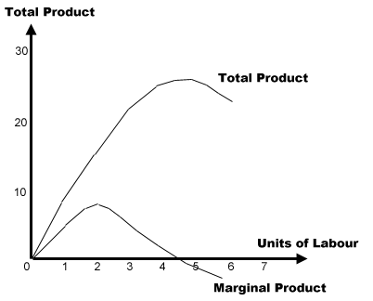

Total Cost Curves

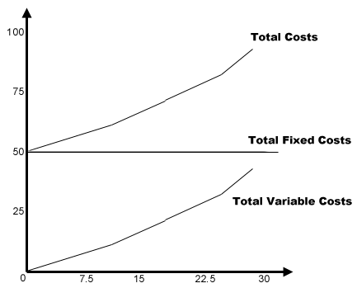

Tennis Ball Average Cost Curves

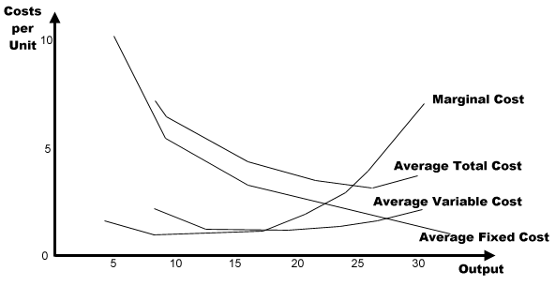

Appendix 1 - Continue
Figure 3
Worksheet #2: Secondary Changes in the Money Supply

1 $200m new money created by the primary increase in the money supply flows into the Registered Bank. Use the required reserve ratio (R) to show the effect of the lending process on the money supply as this new money works through the banking system.

2 Total each column and write the answer in the space provided (Total 1)

Registered Bank R=0.1 (0.2, 0.25, 0.50)

DEPOSITS | LOANS | RESERVES

Total 1 ________________ ___________________ ____________________

3 Calculate the credit multiplier. Use it and the original deposit ($200m) to calculate the total change in the money supply, loans and reserves that would occur if the bank continued all the lending rounds. Enter these totals in the spaces below. (Total 2)

Total 2 ________________ ___________________ ____________________

Comment:

Extension Exercise

INITIAL REGISTERED BANK BALANCE SHEET $ R = 0.1

Reserves 1000 Transaction Accounts 10,000
Loans 9000

Total 10,000 Total 10,000

As a result of the transactions that have taken place in the economy there is a primary increase in the money supply of $200. Complete the balance sheet below to show the impact of this increase after the credit creation process of the registered bank that leaves the registered bank fully loaned up.

REGISTERED BANK BALANCE SHEET $ R = 0.1

Reserves Transaction Accounts
Loans

Total Total

Break

INITIAL REGISTERED BANK BALANCE SHEET $ R = 0.2

Reserves 1000 Transaction Accounts 5,000
Loans 4000

Total 5,000 Total 5,000

As a result of the transactions that have taken place in the economy there is a primary increase in the money supply of $200. Complete the balance sheet below to show the impact of this increase after the credit creation process of the registered bank that leaves the registered bank fully loaned up.

REGISTERED BANK BALANCE SHEET $ R = 0.2

Reserves Transaction Accounts
Loans

Total Total
Break

INITIAL REGISTERED BANK BALANCE SHEET $ R = 0.25

Reserves 1000 Transaction Accounts 4,000
Loans 3000

Total 4,000 Total 4,000

As a result of the transactions that have taken place in the economy there is a primary increase in the money supply of $200. Complete the balance sheet below to show the impact of this increase after the credit creation process of the registered bank that leaves the registered bank fully loaned up.

REGISTERED BANK BALANCE SHEET $ R = 0.25

Reserves Transaction Accounts
Loans

Total Total

Break

INITIAL REGISTERED BANK BALANCE SHEET $ R = 0.5

Reserves 1000 Transaction Accounts 2,000
Loans 1000

Total 2,000 Total 2,000

As a result of the transactions that have taken place in the economy there is a primary increase in the money supply of $200. Complete the balance sheet below to show the impact of this increase after the credit creation process of the registered bank that leaves the registered bank fully loaned up.

REGISTERED BANK BALANCE SHEET $ R = 0.5

Reserves Transaction Accounts
Loans

Total

