Statistics for Geography and Environmental Science: an introduction in R
Richard Harris
http://www.social-statistics.org
August 2011

Copyright Notice

You are free:
to Share — to copy, distribute and transmit the work
to Remix — to adapt the work

Under the following conditions:
Attribution — You must attribute the work by inserting the following text clearly at the front of any derivative: Based on v.1 of Statistics for Geography and Environmental Science: an introduction in R by Richard Harris, written to support the textbook Statistics for Geography and Environmental Science (Harris & Jarvis, 2011), with updates at http://www.social-statistics.org.
Noncommercial — You may not use this work for commercial purposes with the exception of teaching and training courses at Universities and recognised Higher Education institutions.
Share Alike — If you alter, transform, or build upon this work, you may distribute the resulting work only under the same or similar license to this one. You are requested but not required to send a copy of any derivative work to rich.harris@bris.ac.uk.

With the understanding that:
Waiver — Any of the above conditions can be waived if you get permission from the copyright holder.
Public Domain — Where the work or any of its elements is in the public domain under applicable law, that status is in no way affected by the license.
Other Rights — In no way are any of the following rights affected by the license:
- Your fair dealing or fair use rights, or other applicable copyright exceptions and limitations;
- The author's moral rights;
- Rights other persons may have either in the work itself or in how the work is used, such as publicity or privacy rights.
Notice — For any reuse or distribution, you must make clear to others the license terms of this work.

Session 2. Descriptive statistics

Summary
Descriptive statistics are those that summarise key characteristics of the variables in a data set. They include measures of average and of variation around that average, and are supported and presented in summary tables or by using graphics. This session looks at simple ways to make sense of and present data in R.

In this session you will
- Learn how to produce simple descriptive statistics in R,
- Learn how to produce and to customise simple graphs in R.

Creating a frequency table and a bar chart
Open R and load the workspace saved at the end of the last session. Also load the library, library(SGES). If you forgot to save the workspace, follow these steps,
library(SGES)
data(rabies)
names(rabies)[2] = "incidents"
The incidents variable is the number of cases of human rabies in the US during each of the years 1975-2005. It is discrete, integer data, as the following confirms.
class(rabies$incidents)
Discrete and also continuous data are defined in Key concept 2.2 of Statistics for Geography and Environmental Science (SfGES, p. 21).
Because the data are discrete they can be gathered into a frequency table that will show the number of years there was no incident of human rabies, the number of years with one incident, the number with two, three, and so forth.
table(rabies$incidents) # Cf. Table 2.3 of SfGES, p. 22
The same data can also be presented as a bar chart
barplot(table(rabies$incidents))
which can be customised (type ?barplot for further details). For instance,
barplot(table(rabies$incidents), col="light blue", border="dark blue", xlab="Number of cases", ylab="frequency", las=1)
# las=1 prints the axis values horizontally on the chart
Or, to produce the chart shown in Figure 2.1,
barplot(table(rabies$incidents), col="light blue", border="dark blue", xlab="Number of cases", ylab="frequency", yaxt="n")
# Remember you can use the ↑ key to scroll back and make changes
# to previous commands
axis(2, at=table(rabies$incidents), las=1)
which works by initially suppressing the drawing of the vertical, y-axis using the argument yaxt="n" and then draws it but adding the tick-marks (the values on the axis) at only those that appear in the frequency table.
Don't be put-off by the code. Familiarity comes with practice. The purpose remains to learn by doing and also to get a sense of how easy it is to customise graphics.

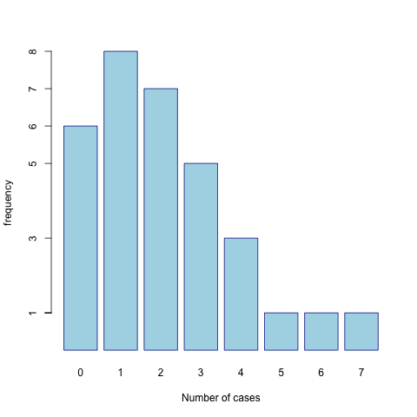
Figure 2.1. A customised bar plot showing the distribution of the human rabies data. It was most common for there to be one incident of the disease in the years 1974-2005 but the number ranges from zero to seven.

Creating a histogram
In contrast to discrete data, a characteristic of continuous data is that there are too many different values for it make sense to count how often each appears. For an example of this, load a data set recording the number of days in 2007 when ozone was the main air pollutant in various US counties and plot it as a bar plot:
data(ozone)
head(ozone)
barplot(table(ozone$days)) # Cf. Figure 2.2 in SfGES p. 26
This is not good! It makes more sense to gather the values into groups and then show how prevalent the group is within the data. That is what a histogram does.
hist(ozone$days)
hist(ozone$days, xlab="Number of days", col="light blue", border="dark blue")
Or, with more customisation
histogram1 = hist(ozone$days, xlab="Number of days", col="light blue", border="dark blue", yaxt="n", main="Number of days ozone was the main air pollutant in US Counties in 2007")
axis(2, at=histogram1$counts, las=1)
To which a rug plot can be added to indicate the individual data values (cf. Key concept 2.4 in SfGES, p. 30) and produce the chart shown in Figure 2.2.
rug(ozone$days, col="dark blue")
You might like to compare the histogram with a stem and leaf plot (see Figure 2.7 of SfGES, p. 31).
stem(ozone$days)
hist(ozone$days, breaks=19)
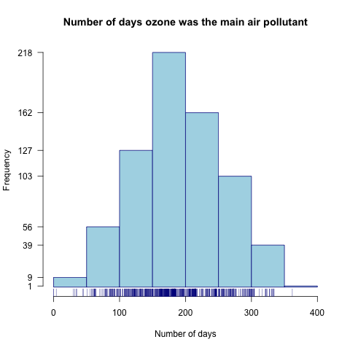
Figure 2.2. A customised histogram with a rug plot showing the distribution of the ozone data (number of days ozone was the main air pollutant in various US Counties in 2007) (Data source: Environmental Agency, 2008).

Six Number Summary and box plots
A six number summary gives the range of the data (from minimum to maximum), the interquartile range (the 'middle half' of the data) and two measures of central tendency, the mean and the median. In addition, and where applicable, the number of missing data (NAs) will be displayed.
summary(ozone$days) # Cf. Key concept 2.12 in SfGES p. 41
The six number summary underpins the logic of a box plot where the middle box of the plot shows the interquartile range (IQR) with the median within it, and where the whiskers either extend out to the minimum and maximum values or, if they stop short, help identify skewed data (when there are more higher values than there are lower ones, or vice versa) and/or potentially unusual data values.
boxplot(ozone$days)
This is better drawn horizontally (it is easier to read from side-to-side and then down). A rug plot can be added.
boxplot(ozone$days, horizontal=T, xlab="Number of days")
rug(ozone$days) # Cf. Figure 2.10 in SfGES p. 39
There are three counties (but it looks like two) with values outside the whiskers. Those counties can be identified from the column of data with the county names:
head(ozone)
outliers = which(ozone$days < 10)
outliers
ozone$county[outliers]
Again, the plot can be customised, in the following example by changing the tick-marks to emphasise key values on the axis.
boxplot1 = boxplot(ozone$days, horizontal=T, xlab="Number of days", xaxt="n")
axis(1, at = boxplot1$stats)
rug(ozone$days)
Finally, since the dataset also lists each county's state so the data can be grouped by state to see if some have more days with ozone as the main air pollutant than others.
with(ozone, tapply(days, state, summary))
with(ozone, boxplot(days ~ state, horizontal = T, las=1))
# The tilde, ~, means to group the data, here by state
# You may wish to use your mouse to resize the graphic
These commands are equivalent to typing
tapply(ozone$days, ozone$state, summary)
boxplot(ozone$days ~ ozone$state, horizontal = T, las=1)

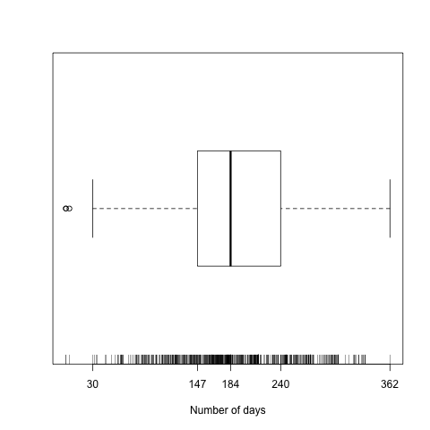
Figure 2.1. A customised box plot with a rug plot showing the distribution of the ozone data (number of days ozone was the main air pollutant in various US Counties in 2007) (Data source: Environmental Agency, 2008).

Attaching data
Typing ls() lists all the objects in the workspace. It currently will include the ozone data at a minimum. Typing names(ozone) will list the variable names.
Try typing summary(days). It will generate an error message because you are trying to run the function summary() with an object that does not exist within the workspace. The object that does exist is ozone. It, not the workspace, contains a variable (a column of data) called days.
To specify that days is a variable within the object ozone the form function(object$variable) is used. For example,
summary(ozone$days)
An alternative is
with(ozone, summary(days))
A third alternative is to attach the data which allows R to treat the variable names as though they are themselves objects.
attach(ozone)
summary(days)
You can attach more than one dataset at a time though it will become confusing and generate a warning about masking if those data sets have one or more variable name in common, or if you attach a data set with a variable name that is the same as an object within the workspace. To help prevent this, detach a dataset after using it:
detach(ozone)

TIP! If you get an error message saying an object is not found it may be because you've forgotten to attach the data

Strip charts and measures of central tendency
Measures of central tendency, generally referred to as averages, measure the centre of a dataset. To see this, begin by drawing a strip chart showing the complete spread of data values:
stripchart(ozone$days, xlab="Number of days")
This shows the spread but isn’t very good because some values coincide and are drawn over each other. To resolve this they can be separated out from each other,
stripchart(ozone$days, xlab="Number of days", method="stack", at=0.75)
Or,
stripchart(ozone$days, xlab="Number of days", method="jitter")
To this we'll add the mean and median average values (Key concept 2.5 in SfGES, p. 33).
abline(v=mean(ozone$days, na.rm=T), col="dark red", lty="dotted")
abline(v=median(ozone$days, na.rm=T), col="dark blue", lty="dashed")
And a legend
legend("topleft", legend=c("Mean","Median"), lty=c("dotted","dashed"), col=c("dark red","dark blue"))
Both averages are near the centre of the data but result from different ways of defining that centre. Of the two, the mean is sensitive to outliers (see Figure 2.8 in SfGES, p. 33).

Trimmed mean
In the presence of outliers, it can be helpful to trim the mean so that a certain proportion (between 0 and 0.5) of the observations are omitted from each end of the distribution. The following cuts 5% of the data from each end (10% of the data in total).
mean(ozone$days, na.rm=T, trim=0.05)
which differs only slightly from the untrimmed mean
mean(ozone$days, na.rm=T)

Measures of spread and variation
Measures of central tendency are not especially useful without knowledge of how much the data vary around the centre (see Section 2.6 of SfGES for an example of why not, pp. 34 – 35).

The interquartile range (IQR)
The interquartile range orders the data from lowest to highest in value, then quarters the data (see Key concept 27 in SfGES, p. 35).
quantile(ozone$days, na.rm=T)
Which is equivalent to
quantile(ozone$days, probs=seq(from=0, to=1, by=0.25), na.rm=T)
The interquartile range is from 147 days (first quartile) to 240 days (third quartile).
There is no particular reason to choose quartiles as opposed to, say, quintiles (splits the data into fifths) or deciles (splits the data into tenths). For these use
quantile(ozone$days, probs=seq(from=0, to=1, by=0.2), na.rm=T)
quantile(ozone$days, probs=seq(from=0, to=1, by=0.1), na.rm=T)
For percentiles (splits the data into hundredths), use
quantile(ozone$days, probs=seq(from=0, to=1, by=0.01), na.rm=T)

The standard deviation and the variance
The standard deviation is a measure of average variation around the mean. It is also the square root of the variance. Both are explained fully in Section 2.6 of SfGES, pp. 38 – 38.
var(ozone$days, na.rm=T) # Calculates the variance
sqrt(var(ozone$days, na.rm=T))
# Calculates the square root of the variance. Which is the
# standard deviation …
sd(ozone$days, na.rm=T)
round(sd(ozone$days, na.rm=T), 2)
# Rounds the result to two decimal places

Missing data
The summary table, summary(ozone$days) shows that the variable contains missing data. It is because of this that it is necessary to include the argument na.rm=T to calculate the mean, mean(ozone$days, na.rm=T) and the median, median(ozone$days, na.rm=T), the IQR, and so forth.
An alternative would be to create a new variable that omits the missing data and does the calculations for that instead.
is.missing = is.na(ozone$days)
# A logical statement. Will be TRUE where the data are missing
# otherwise FALSE
is.missing
ozone.data = ozone$days[!is.missing]
# The days of ozone where the data are not missing
# (here ! means not)
rm(is.missing)
# We don't need this object anymore so can remove it
mean(ozone.data)
median(ozone.data)
quantile(ozone.data)
var(ozone.data)
sd(ozone.data)
Another is to go through the data and identify those rows where the data are complete
is.complete = complete.cases(ozone)
# A logical statement. Will be TRUE where the data are complete
# otherwise FALSE
ozone2 = ozone[is.complete, ]
rm(is.complete)
mean(ozone2$days)
median(ozone2$days)
# etc.

Tidying-up and saving the workspace
You can, if you wish, now close R without saving the workspace. However, if you are continuing on to the next session now is a good time to tidy the workspace.
Type ls() to list all the objects in the workspace. The only one we shall use for the next session is the one called ozone. The rest can be deleted using a command of the form
rm(boxplot1, outliers, ozone2, rabies)
ls()
Complete the session by saving the workspace with a name such as session2.RData
save.image(file.choose(new=T))

TIP: For future sessions, get into the habit of saving the workspace regularly as you go along. Use a naming convention like session2_1.RData, session2_2.RData, session2_3.RData, etc. so you can easily go back to when the workspace was saved if it becomes necessary to do so.

Directed reading
Read Chapter 2 of the textbook Statistics for Geography and Environmental Science to:
- Gain a better understanding of different types of data and how these affect the types of analysis that are possible or sensible for the data.
- Understand how various measures of central tendency and of spread are derived and the logic behind them.

