Statistics for Geography and Environmental Science: an introduction in R
Richard Harris
http://www.social-statistics.org
August 2011

Copyright Notice

You are free:
to Share — to copy, distribute and transmit the work
to Remix — to adapt the work

Under the following conditions:
Attribution — You must attribute the work by inserting the following text clearly at the front of any derivative: Based on v.1 of Statistics for Geography and Environmental Science: an introduction in R by Richard Harris, written to support the textbook Statistics for Geography and Environmental Science (Harris & Jarvis, 2011), with updates at http://www.social-statistics.org.
Noncommercial — You may not use this work for commercial purposes with the exception of teaching and training courses at Universities and recognised Higher Education institutions.
Share Alike — If you alter, transform, or build upon this work, you may distribute the resulting work only under the same or similar license to this one. You are requested but not required to send a copy of any derivative work to rich.harris@bris.ac.uk.

With the understanding that:
Waiver — Any of the above conditions can be waived if you get permission from the copyright holder.
Public Domain — Where the work or any of its elements is in the public domain under applicable law, that status is in no way affected by the license.
Other Rights — In no way are any of the following rights affected by the license:
- Your fair dealing or fair use rights, or other applicable copyright exceptions and limitations;
- The author's moral rights;
- Rights other persons may have either in the work itself or in how the work is used, such as publicity or privacy rights.
Notice — For any reuse or distribution, you must make clear to others the license terms of this work.

Session 4. Inferential Statistics and Hypothesis Testing

Summary
A commonly used idea in statistics is that the data we are describing are (unbiased) samples of a wider population. For example, a survey on voting behaviour does not ask all the population how they intend to vote, and nor does it need to do so to get precise estimates of the likely election day result, provided those who are asked are together representative of the population whole.
Inferential statistics look beyond describing data in their own right to gathering information about the properties of the system, process or structure that have been measured. They also introduce the distinction between a sample of the population and its characteristics, and the population itself and its characteristics. For example, between the sample mean and sample standard deviation, and the population mean and population standard deviation. Usually the population is too large (or abstract) for us to know what its true mean and standard deviation are. However, we can make inferences based on what we know about the sample.
Formal tests are used to see if a sample plausibly could be from a population of a hypothesised mean, to test whether two samples could be from the same population, and to generate evidence about whether two or more samples are categorically different from each other.

In this session you will
- Learn how to undertake hypothesis testing in R, with a focus on t tests and Analysis of Variance (ANOVA)

One sample t test
Load the data called sample.data and inspect it,
library(SGES)
data(sample.data)
head(sample.data)
tail(sample.data)
nrow(sample.data)
ncol(sample.data)
names(sample.data)
summary(sample.data)
The dataset contains two samples of data, each with 100 observations, and distinguished by the letters A or B.
One of these samples is from a population with a mean of 500 (it could be mean height above sea level in metres for example). The other isn't. But which is which?
One clue is to calculate the sample means,
attach(sample.data)
mean(x[sample == "A"])
mean(x[sample == "B"])
or
tapply(x, sample, mean)
On the basis that its sample mean is closer to 500, perhaps it's B. Possibly but we need also to consider the spread of the data around their means. This can be viewed visually. For example,
boxplot(x ~ sample, horizontal = T)
rug(x[sample == "A"], side = 1)
rug(x[sample == "B"], side = 3)
abline(v = 500, lty = "dotted")
Now looking at the overlap in the sample data it is hard to distinguish between them or to say that it is really B and not A that comes from the population with mean of 500.
This is where the one-sample t test comes in as we can formally test each sample against the null hypothesis that it is from a population with mean equal to 500.
t.test(x[sample == "A"], mu=500)
# mu is the population mean we are testing against
t.test(x[sample == "B"], mu=500)
The p value shown on screen can be interpreted as the level of mistake we are making (on a scale from 0 to 1) if we reject the null hypothesis. Commonly the null hypothesis is only rejected if p is less than 0.05 or, for more confidence in the decision, less than 0.01.
For sample A, the test score is t = 2.2638 with 99 degrees of freedom and the probability this is 'due to chance' is p = 0.02577. We can reject the null hypothesis of the population mean being equal to 500, therefore accepting the alternative hypothesis that it isn't.
For sample B, the test score is t = 1.184 with 99 degrees of freedom and the probability this is 'due to chance' is p = 0.2392. This is too high to reject the null hypothesis.
Of the two samples, it is more probable that sample B is from a population with mean equal to 500.

Confidence intervals
Also shown in the screen output is a range of values, the confidence interval, within which the population mean is likely to fall. Here we know that the population mean is 500. However, more often the population mean is unknown so it is useful to have an estimate of what it could be. Note that the 95% confidence interval for sample A is from 505.7678 to 587.6462 (though that level of precision is spurious). Because the interval does not include 500 we conclude that sample A most likely is not from a population with mean of 500. In contrast, the interval for sample B, from 483.5647 to 565.0713 does include 500.
The confidence interval can be extended. For example, the 99% confidence intervals are determine using
t.test(x[sample == "A"], mu=500, conf.level=0.99)
t.test(x[sample == "B"], mu=500, conf.level=0.99)
Note that with a 99% confidence interval that ranges from 492.5179 to 600.8961 we no longer reject the null hypothesis that sample A is from a population with mean of 500 (and we still don't reject it for sample B).
It may be helpful to visualise the confidence intervals. The following code does so:
stripchart(x ~ sample, method="jitter", col="gray50")
mean.A = mean(x[sample == "A"])
mean.B = mean(x[sample == "B"])
points(mean.A, 1, pch=21, bg="red", cex=2)
points(mean.B, 2, pch=21, bg="red", cex=2)
# Draws the sample means on the strip chart
se.A = sd(x[sample == "A"]) / sqrt(100)
se.B = sd(x[sample == "B"]) / sqrt(100)
# Calculates the standard error for each sample
# (see Section 5.7 of SfGES, pp. 123)
arrows(mean.A - 1.96*se.A, 1.01, mean.A + 1.96*se.A, length=0.2, angle=90, code=3, lwd=2)
# Draws the 95% confidence interval for sample A
arrows(mean.A - 2.58*se.A, 0.99, mean.A + 2.58*se.A, length=0.2, angle=90, code=3, lwd=2)
# Draws the 99% confidence interval for sample A
arrows(mean.B - 1.96*se.B, 2.01, mean.B + 1.96*se.B, length=0.2, angle=90, code=3, lwd=2)
# Draws the 95% confidence interval for sample B
arrows(mean.B - 2.58*se.B, 1.99, mean.B + 2.58*se.B, length=0.2, angle=90, code=3, lwd=2)
# Draws the 99% confidence interval for sample B
abline(v = 500)
# Adds a line at the hypothesized value of 500
Especially if you resize the graphic (stretch it so it is wider) it should be clear that whereas both the 95% and 99% confidence intervals include the possible population mean of 200 for sample B, the same is not true for sample A. At a 95% confidence we can reject the possibility that sample A is drawn from a population will mean of 500. However, at a 99% confidence interval we cannot.
Confidence intervals are discussed further in Sections 5.5 – 5.11 of SfGES (pp. 120 – 132).
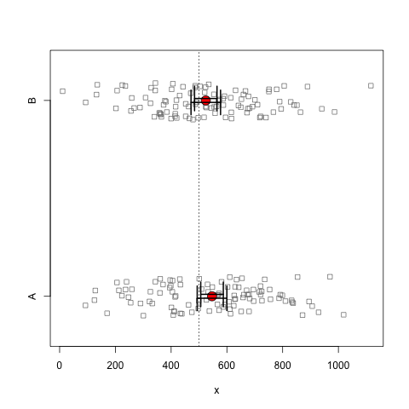
Figure 4.1. Showing the 95% and 99% confidence intervals around the sample mean for two samples of data. (Data source: based on data from the Department for Education)

Two-sample t test
Figure 4.2 (which is a version of Figure 6.3 in SfGES, p. 148), shows a neighbourhood deprivation score for two samples of pupils, the first of which is of students who score lowest in standardised tests taken prior to laving primary/elementary school. The second sample is of those who score highest. Looking at the mean score for the two samples, on average the pupils who do worse in the tests are living in more income deprived neighbourhoods. However, there clearly is overlap between the two groups.

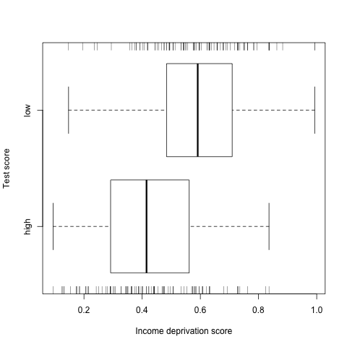
Figure 4.2. Box plots showing a measure of income deprivation for two samples of pupils, one that scored very highly in standardised tests, and one that that scored low.

data(income.deprivation)
summary(income.deprivation)
detach(sample.data)
# We will not be using this dataset any further
attach(income.deprivation)
tapply(deprivation, attainment, mean)
tapply(deprivation, attainment, sd)
boxplot(deprivation ~ attainment, horizontal = T, xlab="Income deprivation score", ylab="Test score")
rug(deprivation[attainment == "high"], side = 1)
rug(deprivation[attainment == "low"], side = 3)

The two-sample t test is used to test if two samples could have been drawn from the same population or if there is evidence that they are categorically different.
t.test(deprivation ~ attainment)
The null hypothesis is that there is no difference between the two sample means. Here we can reject that hypothesis with a more than 95% confidence (the p value is less than 0.05 and the 95% confidence interval does not include zero; it ranges from -0.2138 to -0.1196). The inference is that the two samples are different: that children who do worse in the tests are more likely to be from poorer neighbourhoods than those who do best. From the p value it can be seen that the same conclusion would be reached at a 99% confidence (because p is less than 0.01). However, we can check and find that the confidence interval still does not include zero.
t.test(deprivation ~ attainment, conf.level = 0.99)
Here, and above, the t test works because we have a column of data called deprivation and a second called attainment that is a categorical variable used to distinguish the data in one sample from the data in the other.
Imagine the data were not stored in this way but separately as two objects in R. We can create two such objects,
low = deprivation[attainment == "low"]
high = deprivation[attainment == "high"]
detach(income.deprivation)
rm(income.deprivation)
Looking in the workspace, using ls(), they should now be there. Both are simply a numeric vector of numbers
low
class(low)
high
class(high)
To run the t test with these, use
t.test(high, low)
t.test(high, low, conf.level = 0.99)
To work the other way and combine the two objects into a single data table (a data frame) first the objects need to be combined.
deprivation = c(low, high)
deprivation
Then a categorical variable needs to be created to distinguish the two samples. Each contains 100 students (use length(low) and length(high) to check this) so
attainment = c(rep("low", times=100), rep("high", times=100))
# rep is short for repeat
attainment
Finally the two variables can be combined in a data frame
income.deprivation = data.frame(deprivation, attainment)
class(income.deprivation)
head(income.deprivation)
which can take us full circle
attach(income.deprivation)
t.test(deprivation ~ attainment, conf.level = 0.99)

One-tailed tests
Given knowledge of the links between material and educational disadvantage we could have anticipated not just that there would be a difference between the two samples of pupils but also that that the lower performing students would, on average, be from the most disadvantaged areas. Rather than simply testing to see if the two samples are drawn from different populations (ones with different levels of income deprivation) we can more explicitly test to see if those pupils with lowest attainment are from areas with greater income deprivation (on average). Instead of a two-tailed test of difference we will use a one-tailed test (see Section 6.3 and Key concept 6.4 in SfGES, pp. 142 – 143).
The categorical variable attainment contains two values which, in alphabetical order, are high and low (use levels(factor(attainment)) to confirm this). The hypothesis is that the first of these groups (those who have high test scores at school) will be from neighbourhoods with less income deprivation:
t.test(deprivation ~ attainment, alternative = "less")
The screen output is the same as before except the p value has halved (it always will) and the confidence interval now begins at negative infinity. See Section 6.3 of SfGES for an explanation (p. 142).
The test can also be run using the vector objects created previously
t.test(high, low, alternative = "less")
# We believe the high scoring pupils are from neighbourhoods
# with less income deprivation, on average
Or, if preferred,
t.test(low, high, alternative = "greater")
# Reciprocally, we believe the low scoring pupils are from
# neighbourhoods with greater income deprivation, on average

F test
By default R assumes that the two samples of data used for the t test have unequal variances. If this not true and the two samples do have approximately equal variances then a better estimate of the p value can be obtained by running the test in the form
t.test(deprivation ~ attainment, var.equal=T)
or
t.test(low, high, alternative = "greater", var.equal=T)
etc.
To test whether the two variances are sufficiently equal, an F test is used. The null hypothesis is that the variances of the populations from which the two samples are drawn are equal.
var.test(deprivation ~ attainment)
var.test(low, high)
The probability we would make a mistake by rejecting the null hypothesis is high (p = 0.6679) and well above the threshold typically used to reject it (p < 0.05). Therefore we retain the null hypothesis of equal variance and use the equal variance t test in preference to the unequal one (Cf. Section 6.5 of SfGES, pp. 147 – 152).

TIP: A paired t test is undertaken using code of the form t.test(x, y, paired=T, …). See ?t.test and Section 6.6 of SfGES (p. 152 – 153) for more details.

Analysis of Variance (ANOVA)
An ANOVA is used to test the null hypothesis that three or more samples or groups of data have an equal population mean.
Figure 4.3 shows the life expectancy at birth of males in 117 countries grouped by a classification of their gross national income per capita.
data(life.expectancy)
attach(life.expectancy)
stripchart(Years ~ Income.group, method="stack", xlab="Life expectancy (years)")
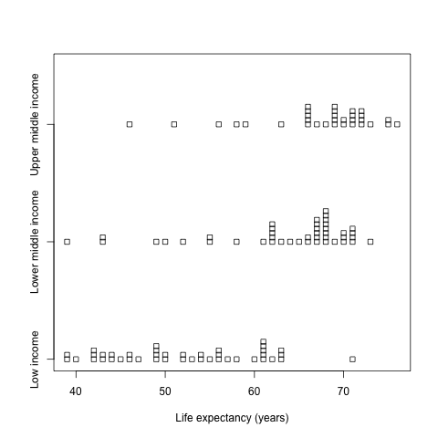
Figure 4.3. Life expectancy at both of males in 117 countries grouped by national income. (Data sources: UN data and World Bank, 2009).

It is suspected that there are statistically significant differences of average life expectancy between the three groups and that hypothesis will be tested with an ANOVA. The ANOVA works by looking at the variation between groups, compared to the variation within groups. The greater the former relative to the latter, the more we can say there is something categorically different about the groups (they overlap less in terms of their data values).
summary(aov(Years ~ Income.group))
Here the summary shows that the between group variation (BSS, the between group sum-of-squares) is 4782.1 with 2 degrees of freedom. The within group variation (WSS, the within group sum-of-squares) is 6989.1 with 114 degrees of freedom.
The F value is equal to (4782.1 / 2) / ( 6989.1 / 114) = 39, as shown on screen. The probability that value arises due to chance is tiny so the null hypothesis of no differences between the groups is rejected.
The group effect can be measured as BSS / (BSS + WSS)
effect = 4782.1 / (4782.1 + 6989.1)
effect
which, at 0.41 is small-to-medium though still important.
See Section 6.7 of SfGES for further information about ANOVA, pp. 153 - 157

Using contrasts
The ANOVA indicates the groups haven't the same population mean but does not show if any one group is especially different from the rest. Contrasts are used to make specific comparisons of one or more groups with one or more of the rest.
There are three groups in the life expectancy data:
levels(factor(Income.group))
To contrast the low income group with both the middle income groups,
contrasts(Income.group)
contrasts(Income.group) = cbind(c(-1,0.5,0.5), c(-1,0.5,0.5))
# The cbind() function binds data into columns.
contrasts(Income.group)
The middle income groups (columns 1 and 2) are set to contrast with the lower income group but not with each other (cf. SfGES, p. 157).
summary(aov(Years ~ Income.group))
This gives an F statistic of 70.8 with 1 and 115 degrees of freedom and a p value that leads us to reject the null hypothesis of no difference in life expectancy of the low income group Vs the middle income groups.
Contrasting the two middle income groups with each other whilst omitting the low income group entirely,
contrasts(Income.group) = cbind(c(0,-1,1), c(0,-1,1))
contrasts(Income.group)
summary(aov(Years ~ Income.group))
This gives an F statistic of 1.26 with 1 and 115 degrees of freedom and a p value of 0.2645. That is too great to reject the null hypothesis of no difference in life expectancy of the middle income groups. Overall, and not unsurprisingly, the important difference is between the low income group and the rest.
Finally, to reset the contrasts
contrasts(Income.group) = NULL
detach(life.expectancy)

Non-parametric tests
When using the t tests it is assumed that the samples are drawn from Normally distributed populations. Although some departure from Normality is reasonable there will be times when then assumption is not warranted (Cf. SfGES, Section 6.8, pp. 157 – 159).
A statistical test of Normality is the Shapiro-Wilk test with the null hypothesis that the data are from a Normal population. We would therefore prefer not to reject the null hypothesis.
Applying the test to the income deprivation scores considered earlier, they do appear to be Normal:
shapiro.test(income.deprivation$deprivation)
# The p value is too high to reject the null hypothesis
Had they not have been we could have considered the Wilcoxon rank sum test (also known as the Mann-Whitney test) instead. For example,
with(income.deprivation, wilcox.test(deprivation ~ attainment))
with(income.deprivation, wilcox.test(deprivation ~ attainment, alternative="less", conf.int=T, conf.level=0.99))
Comparing the non-parametric test with its parametric counterpart, though the null hypothesis of no difference can still comfortably be rejected the confidence interval is wider and the p value greater for the non-parametric test than for the parametric one:
with(income.deprivation, wilcox.test(deprivation ~ attainment, alternative="less", conf.int=T, conf.level=0.99))
with(income.deprivation, t.test(deprivation ~ attainment, alternative="less", conf.level=0.99))
The life expectancy data, by contrast, does fail the test of Normality.
shapiro.test(life.expectancy$Years)
# The p value is low enough to reject the null hypothesis
# of Normality
A non-parametric alternative for the ANOVA is the Kruskal-Wallis test.
with(life.expectancy, kruskal.test(Years ~ Income.group))
The null hypothesis that the groups of countries all have the same population mean life expectancy is rejected.

Power Analysis
The p value seen in the hypothesis testing above measure the probability of rejecting the null hypothesis when that null hypothesis was, in fact, correct. For the t tests and ANOVA it is a measure of how mistaken we probably are if we conclude that the samples or groups are truly different from each other (drawn from different populations).
Whilst we don't want to reject the null hypothesis when it is, in fact, true, we also don't want to retain the null hypothesis when it is, in fact, false. The probability of correctly rejecting the null hypothesis when it is indeed wrong is the power of the test (see Table 6.1 in SfGES, p. 144).
Power analyses require three of the following to be known: (1) the sample size(s), (2) the effect size or an estimate of it, (3) the chosen significance/confidence level of the test, and (4) the amount of power (ranging from 0 to 1 but usually sought to be around 0.80). If three are known, the fourth can be determined.
The pwr package for R implements power analysis as outlined by Jacob Cohen in 'Statistical Power Analysis for the Behavioral Sciences' Routledge, 2nd edition, 1988).
To install and load the library
install.packages(“pwr”)
library(pwr)
For the two-sample t test of income deprivation measured for one group of low attaining and one group of high attaining pupils the sample sizes are 100 and 100 respectively,
attach(income.deprivation)
length(which(attainment == "low"))
length(which(attainment == "high"))
and the chosen confidence interval can be 95% (a significance level of 0.05). The effect size can be estimated as the difference between the sample means divided by their pooled standard deviation (defined by Equation 6.12 in SfGES, p. 149).
To calculate the difference between the sample means:
low = deprivation[attainment == "low"]
high = deprivation[attainment == "high"]
difference = mean(low) - mean(high)
To calculate the pooled standard deviation we can first write a function,
pooled.deviation = function(x, y) {
numerator = sum((x - mean(x))^2) + sum((y - mean(y))^2)
denom = length(x) - 1 + length(y) - 1
return(sqrt(numerator/denom))
}
and then use it
deviation = pooled.deviation(low, high)
Next, to calculate the effect,
abs(difference) / deviation
# abs() calculates the absolute difference, i.e. it ignores
# any minus signs
which is a very large effect. Finally, to calculate the power of the test,
pwr.t2n.test(n1 , n2, d=0.99 , sig.level=0.05)
It comfortably passes the 0.80 threshold. Imagine, however, that we had a sample of only 10 instead of 100 data values.
pwr.t2n.test(n1=10 , n2=10, d=0.99 , sig.level = 0.05)
This does not pass the threshold. There is insufficient data. In this way, power analysis can be used to give an idea of how much data will be needed for a research study. For example, imagine we were studying what we believed to be medium effect of d = 0.5 and were going to test for differences at a 99% confidence interval (a significance level of 0.01). Samples of size at least 96 are required for the power of the test to be 0.80 or above.
pwr.t.test(d=0.50, sig.level=0.01, power=0.80)
Any less will render the test too powerless. Too much more will be superfluous to requirements.
To learn more about power analyses in R see http://www.statmethods.net/stats/power.html.

Tidying-up
If you are continuing to the next session you can delete the objects created for this one, rm(list=ls()). If you are not continuing right away you can exit R without saving the workspace

Directed reading
Chapter 5 of the textbook Statistics for Geography and Environmental Science considers:
- The difference between a sample and a population, and between what is known and unknown.
- Confidence intervals in more detail.
Chapter 6 considers:
- The process of hypothesis testing and explains what is meant by the null and alternative hypotheses, the alpha value, the test statistic, the critical value, type I errors, type II errors, one and two-tailed tests, and the relationship between power and sample size.

