Statistics for Geography and Environmental Science: an introduction in R
Richard Harris
http://www.social-statistics.org
August 2011

Copyright Notice

You are free:
to Share — to copy, distribute and transmit the work
to Remix — to adapt the work

Under the following conditions:
Attribution — You must attribute the work by inserting the following text clearly at the front of any derivative: Based on v.1 of Statistics for Geography and Environmental Science: an introduction in R by Richard Harris, written to support the textbook Statistics for Geography and Environmental Science (Harris & Jarvis, 2011), with updates at http://www.social-statistics.org.
Noncommercial — You may not use this work for commercial purposes with the exception of teaching and training courses at Universities and recognised Higher Education institutions.
Share Alike — If you alter, transform, or build upon this work, you may distribute the resulting work only under the same or similar license to this one. You are requested but not required to send a copy of any derivative work to rich.harris@bris.ac.uk.

With the understanding that:
Waiver — Any of the above conditions can be waived if you get permission from the copyright holder.
Public Domain — Where the work or any of its elements is in the public domain under applicable law, that status is in no way affected by the license.
Other Rights — In no way are any of the following rights affected by the license:
- Your fair dealing or fair use rights, or other applicable copyright exceptions and limitations;
- The author's moral rights;
- Rights other persons may have either in the work itself or in how the work is used, such as publicity or privacy rights.
Notice — For any reuse or distribution, you must make clear to others the license terms of this work.

Session 5. Correlation and Regression

Summary
Relational statistics ask whether two or more sets of data – variables – are related. Scatter plots are a simple and effective way of detecting a relationship and if it is linear. If it is, a measure of linear correlation can be calculated. A regression model produces a line of best fit summarising the relationship. Multiple regression extends the approach to allow more that one variable to explain another.

In this session you will
- Learn how to calculate correlations in R.
- Learn how to fit regression models in R and about the various tests and visual diagnostics that support the decision-making process.

Scatter plots
Scatter plots are the best way of seeing if two variables exhibit any obvious relationship. For example, there is a negative relationship between the average property price and the percentage of the population with no educational qualifications in the city of Bristol, England.
library(SGES)
data(neighbourhood.data)
names(neighbourhood.data)
head(neighbourhood.data)
attach(neighbourhood.data)
plot(pct.no.qual, property.price)
# Here the X variable comes before the Y. Alternatively,
plot(property.price ~ pct.no.qual)
# Where the Y variable is before the X
There is a positive relationship between the average property price and the percentage of the population with higher educational qualifications
plot(pct.abv.alevel, property.price)
plot(property.price ~ pct.abv.alevel)
Let's now label the axes, add rug plots and a regression line of best fit (considered in more detail below).
plot(property.price ~ pct.abv.alevel, xlab="% Higher Education qualification", ylab="Property price (£000s)")
rug(side=1, pct.abv.alevel)
rug(side=2, property.price)
abline(lm(property.price ~ pct.abv.alevel))
# abline is easy to remember. It sounds like “add line”
We can also identify the outlier by typing the following and right-clicking near the point representing the area of highest property prices (see Figure 5.1).
identify(property.price ~ pct.abv.alevel, labels=neighbourhood.data$ward, n = 1)
# This will allows us to click once on the graph (n = 1)
# and identify a point by its ward name
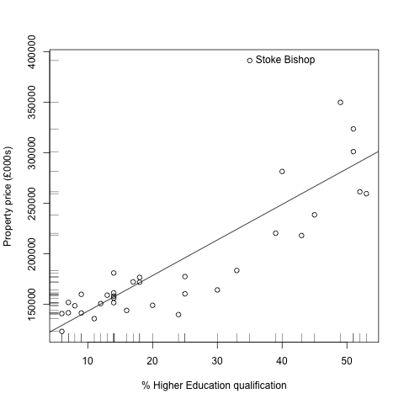
Figure 5.1. Annotated scatter plot showing the positive relationship between the percentage of the population with qualifications above A-level and the average property price for wards in the City of Bristol, England. An outlier (Stoke Bishop) also is shown. (Data source: Venue Magazine, No. 857, 2009, from various other sources).

Mapping the data
The neighbourhood data are also available in the form of a spatial map object (sp), called neighbourhood.map
data(neighbourhood.map)
class(neighbourhood.map)
head(neighbourhood.map@data)
# This is the same data as above. Note that it is stored in
# a part of the object (a slot) called data. Other slots
# define the boundaries of the map.
Because it is a spatial object and thanks to the sp library developed by Edzer Pebesma, Roger Bivand, Barry Rowlinson and Virgilo Gómez-Rubio it is possible to map the data.
spplot(neighbourhood.map, "property.price", cuts=4)
Or, in an orange-to-red scale
orange.scale = brewer.pal(5, "YlOrRd")
# See ?RColorBrewer
spplot(neighbourhood.map, "property.price", cuts=4, col.regions=orange.scale)
And in a gray scale,
gray.scale = brewer.pal(5, "Greys")
spplot(neighbourhood.map, "property.price", cuts=4, col.regions=gray.scale)
In the same way, and this time looking at the percentage of the population without qualifications,
spplot(neighbourhood.map, "pct.no.qual", cuts=4, col.regions=orange.scale)
spplot(neighbourhood.map, "pct.no.qual", cuts=4, col.regions=gray.scale)

TIP! To Learn more about how to read a GIS shapefile into R see
?readShapePoly and ?readShapePoints

PLEASE NOTE: The map is a cartogram created using ScapeToad (http://scapetoad.choros.ch/) based on Census boundary files which are Crown copyright 2003. Please see the licence restrictions at http://tinyurl.com/3gvnsgg.
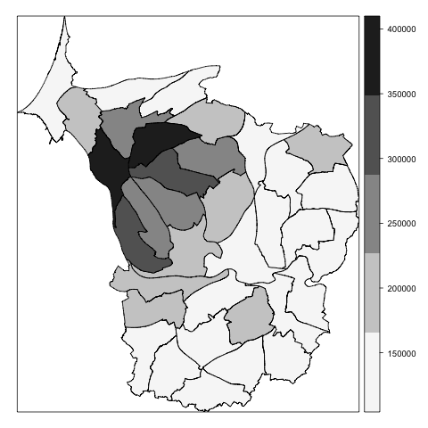
Figure 5.2. A map of property prices in Bristol produced in R.

Correlation coefficient
The strength of the linear relationship between the educational and property price variables can be quantified by calculating a correlation coefficient. Correlation coefficients are discussed in Section 7.4 of Statistics for Geography and Environmental Science (SfGES, pp. 167 – 172).
The Pearson correlation is given using
cor(property.price, pct.abv.alevel)
which observes the positive correlation between the average property price in a neighbourhood and the percentage of the population with higher education qualifications. Reciprocally, the negative correlation between the average property price and the percentage of the population without qualifications is observed from
cor(property.price, pct.no.qual)
The full correlation matrix for all the variables in the neighbourhood.data is given by
cor(neighbourhood.data[,-1]
where the -1 means to exclude the first column of data because it is not numeric. To confirm this: head(neighbourhood.data[,1]
Whether the correlations have arisen due to chance can also be tested
cor.test(property.price, pct.abv.alevel)
cor.test(property.price, pct.no.qual)
where, in both cases, the null hypothesis that the true correlation actually is zero is rejected with a 95% confidence interval, and also at a 99% confidence interval,
cor.test(property.price, pct.abv.alevel, conf.level = 0.99)
cor.test(property.price, pct.no.qual, conf.level = 0.99)
(None of the intervals include zero).
Non-parametric correlation coefficients are calculated by changing the default method as in the following examples where Spearman's and Kendall's rank correlation are calculated:
cor(property.price, pct.abv.alevel, method="spearman")
cor.test(property.price, pct.abv.alevel, method="kendall")

TIP! It is always helpful to view the relationship between two variables as a scatterplot before undertaking a linear correlation analysis because the variables may be related but not linearly so (cf. SfGES, Figure 7.6, p. 171)

Fitting a regression line
The line of best fit shown in Figure 5.1 is a regression line modelling the relationship between the dependent (Y) variable (average property price) and the independent X variable (percentage of the population with higher education qualifications). Although it is unlikely that education itself has an effect on property price, more highly educated persons tend to attract a wage premium that permits them to bid-up the prices of property in desirable neighbourhoods. In this sense we can say that X (higher education) leads to Y (higher property prices), though the relationship could be the other way around (see the discussion in Section 7.3 of SfGES, pp. 165 – 166).
The regression model is fitted to the data as follows,
model1 = lm(property.price ~ pct.abv.alevel, data = neighbourhood.data)
# Here the Y variable is property.price, and the X variable
# is pct.abv.alevel. lm() is short for linear model.
summary(model1)
The model predicts that for every one percent increase in the percentage of the population with higher education qualifications we should expect property prices to rise by £3522.90. The probability that this relationship is due to chance is p < 0.001 (there is greater than 99.9% confidence that the null hypothesis of there being no relationship between the variables can be rejected).
Further discussion on how to interpret the regression output, including the R-squared and F values is given in Section 7.7 of SfGES, pp. 176 – 180.
Having fitted the model it can be added to a scatter plot with the same two variables,
plot(property.price ~ pct.abv.alevel)
abline(model1)

Visual diagnostics
The regression residuals (or errors) are the vertical distances between each point on the scatter plot and the regression line. It is the difference between what the model predicts the Y-variable should be for a given value of X and what the value actually is.
The ordinary least squares regression (OLS) used above assumes that the regression residuals are independently and identically distributed (i.i.d.) which means they should have no explained pattern or structure. To check this, type plot(model1) to work through a series of diagnostic plots.
The first and the third of the plots are equivalent to Figure 7.9d in SfGES, p. 181 and are useful to check for evidence of heteroscedasticity (non constant variance, see Figure 7.13 in SfGES, p. 186).
The second plot is a quantile plot to check whether the residuals are Normally distributed (or approximately so).
The fourth plot identifies extreme outliers and leverage points (see Key concept 7.7 of SfGES, p. 184). As a rule of thumb, a standardised residual greater than two or less than negative two is a concern, and one greater/less than four/negative four, more so. An observation that is drifting towards or over the dotted one contour shown on the plot may be judged to be a leverage point.
It is sometimes helpful to be able to right click on the plots (in Windows) and cut and paste them into another document without them changing to the next plot. To do so, they can be plotted individually,
plot(model1, which = 1)
plot(model1, which = 2)
plot(model1, which = 3)
plot(model1, which = 5)
# Note that the fourth plot is actually the fifth!
Or, you plot them together,
par(mfrow=c(2,2))
plot(model1)
Looking at these plots together, observation 16 especially, and possibly 19, are outliers that may be having a detrimental effect on the model fit. Observation 16 is Stoke Bishop (cf. Figure 5.1, above) and observation 19 is Henleaze: ward[c(16,19)]

Refitting the model with a subset of the observations
To refit the model without observation 16, a subset of the data will be defined that includes all but this observation.
subset1 = rep(T, times = nrow(neighbourhood.data))
subset1
subset1[16] = F
subset1
# All but the 16th value are set to be TRUE. By setting the
# 16th to FALSE it will be omitted from the following model
model2 = lm(property.price ~ pct.abv.alevel, data = neighbourhood.data, subset = subset1)
# Or, alternatively,
model2 = update(model1, . ~ ., subset = subset1)
# . ~ . means use the same Y and X variables as previously
summary(model2)
par(mfrow=c(2,2))
plot(model2)
Taking the visual and on-screen diagnostics together, the model has been improved by removing observation 16. It is further improved by the removal of observation 19.
subset1[19] = F
subset1
# It is now FALSE for the 16th and 19th observations
model3 = update(model1, . ~ ., subset = subset1)
summary(model3)
par(mfrow=c(2,2))
plot(model3)
By the same logic we could now omit observation 14, and then most likely another observation, then another, then.... An important judgement is to know when to stop!

Further checks of the regression assumptions

Test of Normality
The Shapiro-Wilk can be used to check if the residuals are Normally distributed,
shapiro.test(residuals(model3))
The p value is too high to reject the null hypothesis of Normality, which is what we want.

Test of homoscedasticity
The Brausch Pagan tests where the residuals are homo- or heteroscedastic.
bptest(model3)
Here the p value is low enough to reject the null hypothesis of homoscedasticity, which is not what we want. In fact, there is evidence of the problem in the following:
plot(model3, which = 1)
This does not look like random noise around the horizontal zero line.

Test that the residuals are not spatially autocorrelated
We can also map the residuals to look for patterns in them. To do this, we'll need to create a new map that excludes the omitted neighbourhoods, and then link that map to the residual data.
map2 = neighbourhood.map[subset1,]
map2 = SpatialPolygonsDataFrame(map2, data.frame(resids = residuals(model3)))
spplot(map2, "resids", cuts=4, col.regions=orange.scale)
From the map, a Moran plot can be produced to determine if there is evidence of positive or negative spatial autocorrelation amongst the residuals (see Section 7.9 of SfGES, p. 183).
weights.matrix = nb2listw(poly2nb(map2), zero.policy=T)
# Identifies which neighbourhoods share a bounday
moran.plot(map2$resids, weights.matrix)
With both neighbourhoods 16 and 19 omitted there is some evidence of positive spatial autocorrelation in the residuals, though it is not significant at a 95% confidence (the p value is greater than 0.05, though not much so).
moran.plot(map2$resids, weights.matrix, zero.policy=T)
lm.morantest.exact(model3, weights.matrix, zero.policy=T)

Transforming one or more of the variables
A possible explanation for the heteroscedasticity detected above and in model3 is that the variables are not linearly related as the model presumes. In fact, the relationship may actually be curvilinear, as Figure 5.2 now suggests.
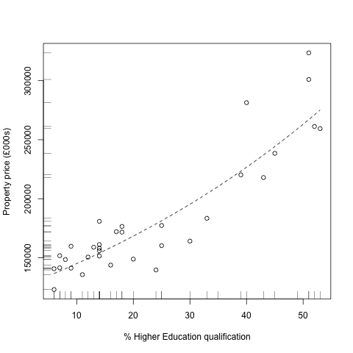
Figure 5.2. The assumption of a linear relationship between the two variables may be unfounded.

Non linear relationships can often be transformed into linear ones. For example,
plot(log10(property.price) ~ pct.abv.alevel, subset=subset1)
model4 = update(model3, log10(property.price) ~ .)
abline(model4)
summary(model4)
This appears to give a better fit. The null hypothesis of homoscedasticity no longer is rejected, which is good.
bptest(model4)

Using dummy variables
Now satisfied that the model meets the assumptions of OLS regression it is worth returning the omitted observations to the model but as dummy variables treating each as a special category of their own.
There are two omitted observations so two dummy variables are required.
neighbourhood16 = rep(0, times = nrow(neighbourhood.data))
neighbourhood16[16] = 1
neighbourhood16
# The dummy variable is a series of zeros with one 1 for the
# 16th observation
neighbourhood19 = rep(0, times = nrow(neighbourhood.data))
neighbourhood19[19] = 1
neighbourhood19
# A series of ones except for the 19th observation
model5 = lm(log10(property.price) ~ pct.abv.alevel + neighbourhood16 + neighbourhood19, data = neighbourhood.data)
summary(model5)
The summary shows us that the average property price (measured on a log scale) in Stoke Bishop (neighbourhood 16) is significantly higher than the rest of the study region, at a greater than 99.9% confidence). The average property price is also significantly higher in Henleaze but less so and at a 95% confidence. These neighbourhoods do appear to be categorically different from the rest.

Multiple regression
As the use of dummy variables has demonstrated, there is no reason why regression should be constrained to only one X variable explaining the Y.
Figure 5.3 gives scatter plots showing the relationship between the log of property price and other variables for neighbourhoods in Bristol. The list of variables is,
The dependent, Y, variable:
property.price Average property price in the ward (based on an Housing survey, 2007)
(log of)
The independent, X, variables:
population Mid-year estimate of the population, 2006 (source, ONS)
crimes Crimes per 1 000 people 2007/8 (source: Safer Bristol Partnership)
pct.no.qual % resident population 16-74 without any academic, vocational or professional qualification (source: ONS, 2001)
pct.abv.alevel % resident population aged 16-74 with a qualification above A level (ONS, 2001)
greenspace Thousands of m2 (ONS Neighbourhood Stats., 2005)
income Average weekly income (£s, source: based on ONS 2001/2 estimates) pct.cycle % resident population aged 16-74 who walk or cycle to work (ONS, 2001) pct.unemp % economically active population that is unemployed (ONS, 2001)
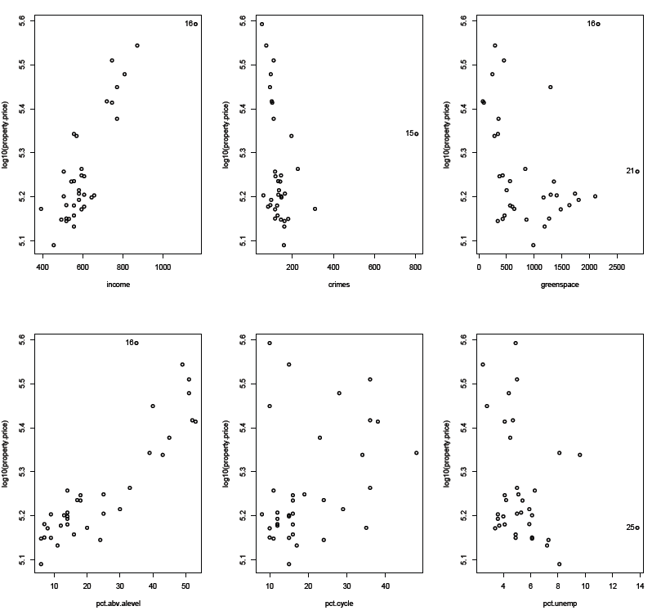
Figure 5.3. Scatter plots indicating the relationship between the Y variable and each potential X variable

Looking at the variables, average property price (logged) appears to have a positive relationship with income, and (as we know) with the percentage of the population with higher educational qualifications. It appears to be negatively related to the crime rate and to the percentage unemployed. The relationship with green space and the percentage that cycle to work is not clear.
As a starting model, we can fit a model including all the X variables as possibly relevant to explaining Y.
starting.model = lm(log10(property.price) ~ income + crimes + greenspace + pct.no.qual + pct.abv.alevel + pct.cycle + pct.unemp, data = neighbourhood.data)
summary(starting.model)
Looking at the summary, a number of the variables do not appear significant at conventional levels of confidence (they have p values about 0.01 or 0.05, for example). The percentage unemployed variable could be dropped in the first instance and the model refitted. However, there are other issues to consider,
vif(starting.model)
Some of the variance inflation factor scores (vif scores) have values above five which, as a rule of thumb, suggests multicollinearity between the X variables (meaning that they are correlated with each other and so are not independent predictors of the Y variable). (See Section 7.15 of SfGES, pp. 190 – 191). It is not surprising to see that the two educational variables, no qualifications and higher qualifications are correlated. They would be by definition: if the percentage of the population with higher education qualifications increases, the percentage without any qualifications must decrease.
A third concern is that there is evidence of outliers and leverage points:
plot(starting.model)
What we do next, whether omitting an observation or a variable from the model is subject to some trial-and-error. A strategy for multiple regression is suggested in Section 7.15 of SfGES, pp. 192 – 193.
For now, let's drop the pct.no.qual variable (it is not significant and has a high vif score).
multiple.model2 = update(starting.model, . ~ -pct.no.qual)
# Update the model but omitting (“taking away”) pct.no.qual.
# Equivalent to
multiple.model2 = lm(log10(property.price) ~ income + crimes + greenspace + pct.abv.alevel + pct.unemp + pct.cycle, data = neighbourhood.data)
summary(multiple.model2)
vif(multiple.model2)
plot(multiple.model2)
Deciding whether the removal of the variable was the right decision requires looking at the summary statistics and visual diagnostic in the round. Has it had much effect on the (adjusted) R-squared value? How about the p values for the other variables? It is logically justified? Does it accord with existing theory? Does the model make sense?
Another aid is to use an F test to compare the regression models.
anova(starting.model, multiple.model2)
In this case the model simplification seems justified because it does not lead to a significant reduction in the explanatory power of the model – the F statistic is insignificant at a 95% confidence level (see Section 7.17 of SfGES, pp. 194).
What next?
Looking at the summary there are three variables that are insignificant predictors of average property price: crime, pct.unemp and pct.cycle. Given its high vif score, pct.cycle is perhaps the best candidate to be omitted next. However, looking at the plots there is clear evidence of a leverage point (neighbourhood 15). Maybe it should be omitted (by specifying a subset of the original data in the same way as we did for the two-variable regression). To re-iterate, some trial-and-error will be required along the path to obtaining a parsimonious model, well fitted to as much of the data as possible.
Once we do have a “final model”, the residuals should be checked for Normality, homoscedasticity and a lack of spatial patterning using the tests discussed earlier.

Standardising the variables
Sometimes, as here, the variables in the model have different measurement scales meaning their effects (the predicted change of Y for a one unit change in the X) cannot directly be compared. To address this it can be advantageous to standardise the data by converting the variables into z values.
To do this, first we'll create a new data.frame including all the contents of neighbourhood.data except the first column (which is a list of names).
regression.data = neighbourhood.data[,-1]
head(regression.data)
Next we'll log the property.price variable,
regression.data$property.price = log10(regression.data$property.price)
head(regression.data)
Now we'll convert each variable to a z value
regression.data = scale(regression.data)
This produces a matrix of values – use class(regression.data) to confirm this – so we'll convert it back to a data.frame.
regression.data = data.frame(regression.data)
We'll now refit the starting model but using the standardised data instead
starting.model2 = lm(property.price ~ income + crimes + greenspace + pct.no.qual + pct.abv.alevel + pct.cycle + pct.unemp, data = regression.data)
Comparing the two models
summary(starting.model)
summary(studying.model2)
the p, R-squared and F values are all the same. However, the estimates of each X variable's effect on the Y have changed, reflecting the change to a common measurement scale. Looking at the model it appears (insofar as the model is correct and hasn't been distorted by outliers, by multicollinearity, etc.) that the percentage of the population with higher education qualifications has the greatest effect on average property prices.

Partial regression plots
The scatter plots shown in Figure 5.3 can be deceptive in the presence of multicollinearity amongst the X variables. Then they don't really show the relationship between the Y and the X alone, but the relationship between them given the effects of all the other variables too. Partial regression plots are used to take out the effects of the other X variables, leaving a better idea of the actual relationship between the Y and X.
For example, imagine we are interested in the relationship between the log of property prices and green space.
First a regression model is fitted including all but the variable of interest.
V = lm(log10(property.price) ~ income + crimes + pct.no.qual + pct.abv.alevel + pct.cycle + pct.unemp, data = neighbourhood.data)
The residuals from this model are what's left in Y once the effects of all the X variables apart from greenspace are taken out.
V = residuals(V)
Next, a second regression model is fitted with greenspace as the dependent variable and all the other Xs are the independent variables,
U = lm(greenspace ~ income + crimes + pct.no.qual + pct.abv.alevel + pct.cycle + pct.unemp, data = neighbourhood.data)
The residuals from this model are what's left in greenspace once the effects of all the other X are taken out.
U = residuals(U)
An idea of the true relationship between property prices and green space can now be show,
plot(V ~ U)
This is actually quite different from our original impression,
plot(log10(property.price) ~ greenspace, data = neighbourhood.data)

'Footnotes'
This session has barely scratched the surface of regression modelling in R. For more about it, including how to fit iteration terms, see An Introduction to R (available from the help menu in R and from http://cran.r-project.org/manuals.html and see Chapter 11. This also includes a discussion of generalised linear models.

Directed reading
Chapter 7 of the textbook Statistics for Geography and Environmental Science considers:
- The logic of regression and the meaning of the various statistical tests and diagnostics used to fit a model.
- The assumptions of regression, how to test if they are met, and what to do if they are not.

