Statistics for Economists

Excel Computing Class III

Aim: The final class will be geared towards correlation and regression in Excel. The data for this session is in table 1 below. Paste the data in excel in cell A1. In cell F1 type 41 (number of obs.) and in cell F2 5% (the alpha we will use)

Table 1
Interest Rate r | Income Y | Money Demand M/P
1.25 | 1496700 | 156.1
1.25 | 1568300 | 168.7
1.25 | 1594200 | 174.6
1.25 | 1650900 | 180.4
1.25 | 1719000 | 183.7
1.35 | 1801000 | 192.6
1.58 | 1853000 | 198.2
1.77 | 1887600 | 198
1.41 | 1884700 | 209.5
1.14 | 1944500 | 216.3
2.79 | 2049800 | 220.5
2.56 | 2150800 | 237.5
2.11 | 2264000 | 254.5
2.31 | 2362500 | 279.1
3.35 | 2526900 | 297.4
3.14 | 2616900 | 318.6
3.88 | 2699600 | 339.6
3.22 | 2804200 | 350.5
2.84 | 2922100 | 375.9
5.28 | 3116100 | 353.5
6.25 | 3314300 | 378.1
3.72 | 3436000 | 420.3
2.51 | 3617400 | 484.2
4.81 | 3831200 | 520.3
9.25 | 3987900 | 552.6
4.68 | 3928600 | 639.4
8.31 | 4147500 | 684.1
5.49 | 4167200 | 741
5.23 | 4281200 | 784.4
7.97 | 4372600 | 804.1
11.22 | 4561200 | 806.1
11.46 | 4516300 | 823.5
11.44 | 4584100 | 855.8
8.18 | 4601800 | 929.8
9.47 | 4699500 | 932.5
8.27 | 4738000 | 962.4
6.64 | 4807600 | 1037.3
5.67 | 4912600 | 1086
5.04 | 5154800 | 1145.9
7 | 5342600 | 1207.4

8.29 5543500 1217

Plotting money demand against income reveals a strong positive relation between the two (check you can replicate the graph below - use the chart - XY scatter option in Excel.)

 |  |  | Money Demand M/P
 | 1400
demand | 1200
demand | 1000
demand | 800 |  |  | Money Demand M/P
demand | 600 |  |  | Money Demand M/P
money | 600
money | 400
money | 200
 | 0
 | 0 | 2000000 | 4000000 | 6000000
 |  | income

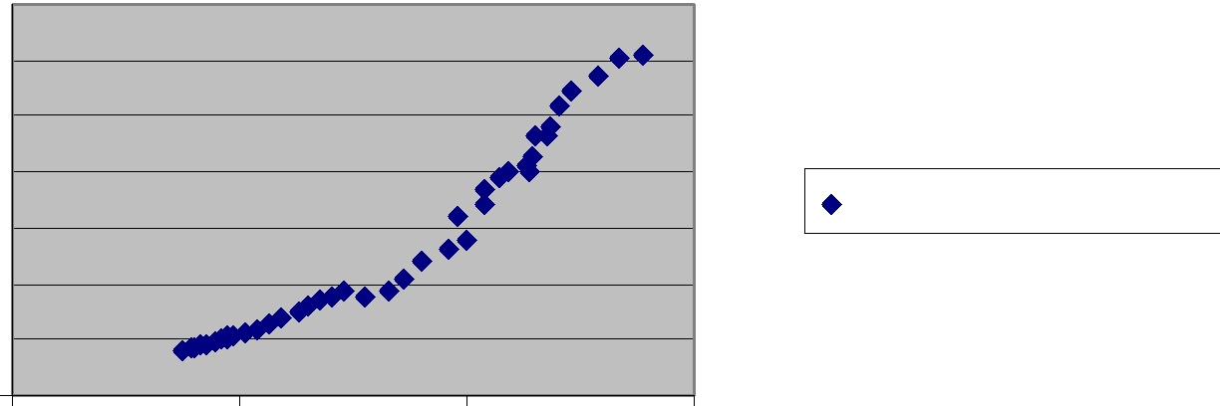

However we often need to present a more specific summary measure of the correlation between two data series. For this we will present two statistics: the Pearson Product Moment Correlation Coefficient and the simple correlation. Below your graph in cell E21 type Pearson and in cell E22 type Correl. Then in F21 you will use the function PEARSON (select the two vectors of interest) and in F22 use the function Correl (select the two vectors). Both in the statistical menu.

Note: the Pearson measures the relationship between two series of data and is scaled to be independent of the units of measurement. Most computations will be based on a sample of observations from a given population, rather than the population itself, and as such it can be computed as:

r_{XY} = ^{sXY}
^{s}x ^{s}Y

where S_{XY} is the sample covariance between X and Y S_{X} is the sample standard error of X
S_{Y} is the sample standard error of y

r_{XY} ranges from -1 to +1 inclusive.

The Pearson correlation coefficient is a useful starting point since it allows us to see the degree of correlation between two data series.

For the data here we can see that both estimators are equal to 0.9693 (check you get this answer) which does indeed imply a very strong and positive relationship between money demand and income.

In all statistical analysis it is essential to employ hypotheses tests. The statistical hypothesis to be tested here is:

H ₀ : ρ |  | XY | = 0
H _{A} : ρ |  | XY | ≠ 0
where |  | ρ_{XY} is the true population correlation coefficient.
if H0 is true then it can be shown that the expression
r | n − 2 |  |  |  | follows a t(n-2) distribution.
XY | 1− r_{XY}²

Type t-stat in F25 and t-crit in G25.

Then in F26

=+F21*SQRT(($F$1-2)/(1-F21^2))

For the t-stat in the case of the Pearson and in F27

=+F22*SQRT(($F$1-2)/(1-F22^2))

For the t-stat in the case of the simple correlation (note than you can scroll down the formula). Since both correlations are the same, the t-stats are the same also.

Using a 5% significance level the critical value of t with 41-2=39 degrees of freedom is 2.021 (in the table you can see the value for 40 d.f.). Hence we can reject the null hypothesis and conclude that the correlation coefficient is indeed significantly different from zero. However, we can calculate the exact t-value in excel. In cell G26 find the function “TINV” and select the paramemters of interest (d.f. and the alpha). The result you obtain is 2.023

Regression.

Now we will use Excel to calculate the regression coefficients for a simple model as follows:
Money demand= a +b*income +e

From the Tools menu, select Data Analysis (If you don’t have this option you need to go to Tools clik Add-Ins and then select Analysis ToolPak. Press Ok). Then scroll down the list of methods and select regression. In the regression menu, type in or select the columns of data for “Y” (ie money demand) and X (ie income), decide if you want the regression output to appear on a new sheet or select a range of data (select a rectangle of around 6 cells) and press OK. I normally use a different sheet, but depends on you.

Your regression output will then appear. You should get something like this...

SUMMARY OUTPUT

Regression Statistics
Multiple R | 0.969303
R Square | 0.939548
Adjusted R
Square | 0.937998
Standard Error | 84.69254
Observations | 41
ANOVA
 |  |  |  |  | Significance
 | df | SS | MS | F | F
Regression | 1 | 4347732 | 4347732 | 606.1393 | 2.26E-25
Residual | 39 | 279740.3 | 7172.827
Total | 40 | 4627473
 |  | Standard |  |  |  | Upper
 | Coefficients | Error | t Stat | P-value | Lower 95% | 95%
Intercept | -326.209 | 37.38105 | -8.72659 1.04E-10 |  | -401.82 | -250.599
income | 0.000261 | 1.06E-05 | 24.6199 | 2.26E-25 | 0.000239 | 0.000282

We can see that income has a positive effect and that the coefficient is statistically significant (t>2).

We could repeat teh above and regress money demand on the interest rate, but that would be boring. Instead do a multiple regression model as follows:

Money demand= a +b *income +c *interest rate +e

Use the same steps but this time select both the income and interest rate columns as the X range. You should get the following:
SUMMARY OUTPUT

Regression Statistics
Multiple R | 0.971949
R Square | 0.944684
Adjusted R
Square | 0.941773
Standard Error | 82.07374
Observations | 41
ANOVA
 |  |  |  |  | Significance
 | df | SS | MS | F | F
Regression | 2 | 4371501 | 2185750 | 324.4831 | 1.3E-24
Residual | 38 | 255971.8 | 6736.099
Total | 40 | 4627473

 |  | Standard |  |  |  | Upper
 | Coefficients | Error | t Stat | P-value | Lower 95% | 95%
Intercept | -358.045 | 39.99368 | -8.95253 | 6.73E-11 | -439.008 | -277.082
interest rate | -14.3853 | 7.658101 | -1.87844 | 0.06801 | -29.8883 | 1.117755
income | 0.000291 | 1.92E-05 | 15.1737 | 1.03E-17 | 0.000252 | 0.00033

If time permits, repeat the steps above for the data from your chosen project topic (one of projects 1 to 9 on study direct).

